

**ICS 344 - Information Security**

Project Final Report

Section 04

Abdulaziz Alshwairkh - 20201332

Almothana Alhussain - 201942870  
Abdullah Alhelwah - 202022760

Turki Almutiri – 201927730

[[Open Presentation]](https://www.canva.com/design/DAGYzj1YB2U/9jhFJtF4NpEZxDvpjfoIZQ/view?utm_content=DAGYzj1YB2U&utm_campaign=designshare&utm_medium=link2&utm_source=uniquelinks&utlId=hf08aaeabeb)

# General

* What service did you target and why?

DVWA’s login page and Apache HTTP server on Metasploitable 2. DVWA is a safe, controlled environment for testing web vulnerabilities, also it is easy to work with. While Metasploitable 2 is already familiar to us from HW1 and it provides various services with known vulnerabilities for practical learning.

* Which honeypot did you target and why?

Owa-honeypot: A simple web-based Outlook honeypot. we targeted this **honeypot** because it mimics the widely used Outlook Web Access (OWA) portal, a frequent target in enterprise environments

* Which SIEM did you use and why?

Splunk. We used thisSIEM because of its powerful data indexing, real-time search, and analysis capabilities. Its ability to handle large volumes of data efficiently makes it ideal for monitoring honeypot activity.

# Setup and Compromise the Service

* How did you configure Caldera?

We used CALDERA as our red-teaming platform. Setting up CALDERA was challenging initially, primarily due to its configuration requirements and integration with the DVWA (Damn Vulnerable Web Application). However, once configured, CALDERA ran smoothly and allowed us to deploy various TTPs

* What MITRE ATT&CK TTPs did you select and how were they applied? Use a table similar to Table 1 in the appendix. Do not write anything you did not apply.

|  |  |  |  |
| --- | --- | --- | --- |
| MITRE ATT&CK Phase | Test | Description | Technique ID |
| Execution | Command and scripting interpreter | Adversaries may misuse command and script interpreters to run commands, scripts, or programs. These tools allow interaction with computer systems and are common across many platforms. | T1059 |
| Initial Access | Exploit Public-Facing Application | Adversaries may try to exploit vulnerabilities in an internet-facing host or system to gain initial access to a network. These vulnerabilities could be caused by software bugs, temporary issues, or misconfigurations. | T1190 |

* Which Kali tools did you use, and how were they integrated into the attack?

We used Nmap for reconnaissance, Metasploit for exploitation. (more details can be found in Phase 1 below)

* What custom scripts did you use, and how were they integrated into the attack?

Custom Python scripts (Requests library) for brute-forcing and directory scanning. (more details can be found in Phase 1 below)

* Which tool/approach (Caldera, Kali tools, Custom scripts) was most effective at compromising the service?

Kali tools

* Were there any limitations in one method that other methods overcame?

CALDERA’s automation lacked flexibility for some specific attacks achievable with custom scripts.

* How successful were you in replicating a real-world attack scenario?

Overall, we successfully replicated common attack scenarios, especially in password guessing and command injection

* What challenges or bugs did you encounter during the setup and attack execution? How did you overcome these issues?

The initial Caldera setup was complex; agent communication issues were frequent. Also, we faced some issues with Caldera’s permissions to access external files. For Metasploitable 2 it was easy and smooth. We overcame this issue by using Absolute file paths implemented to ensure Caldera could access the necessary files.

* How easy or difficult was it to use Caldera compared to Kali tools and manual scripting? How did the level of automation in Caldera affect the overall process? Which approach required the most manual intervention or expertise?

Kali tools and manual scripting were more intuitive and allowed for direct control compared to CALDERA, which required heavy configuration. CALDERA’s automation streamlined repetitive tasks, improving process efficiency. Custom scripts required the most manual input and adjustments. But it was more fun and interesting.

# Setup and compromise the Honeypot

* How did you configure Caldera?

Similar to the service however we configure it with owa-honeypot (More details can be found in Phase2)

* What MITRE ATT&CK TTPs did you select and how were they applied? Use a table similar to Table 1 in the appendix. Do not write anything you did not apply.

|  |  |  |  |
| --- | --- | --- | --- |
| MITRE ATT&CK Phase | Test | Description | Technique ID |
| Execution | Command and scripting interpreter | Adversaries may misuse command and script interpreters to run commands, scripts, or programs. These tools allow interaction with computer systems and are common across many platforms. | T1059 |
| Initial Access | Exploit Public-Facing Application | Adversaries may try to exploit vulnerabilities in an internet-facing host or system to gain initial access to a network. These vulnerabilities could be caused by software bugs, temporary issues, or misconfigurations. | T1190 |
| Credential Access | Brute force (password guessing) | Adversaries may use brute force techniques to gain access to accounts when passwords are unknown or when password hashes are obtained. Without knowledge of the password for an account or set of accounts, an adversary may systematically guess the password using a repetitive or iterative mechanism. | T11110.001 |

* Which Kali tools did you use, and how were they integrated into the attack?

We used Nmap for reconnaissance, Metasploit for exploitation. (more details can be found in Phase 2 below)

* What custom scripts did you use, and how were they integrated into the attack?

Custom Python scripts (Requests library) for brute-forcing and directory scanning. (more details can be found in Phase 2 below)

* Which tool/approach (Caldera, Kali tools, Custom scripts) was most effective at compromising the honeypot?

Kali tools

* Were there any limitations in one method that other methods overcame?

Yes, Caldera's automation excelled in streamlining repetitive tasks, but it was limited by its complexity and steep learning curve. Kali tools and manual scripting, while requiring more manual effort, provided greater flexibility and adaptability for customized attack scenarios.

* How successful were you in replicating a real-world attack scenario?

The replication of a real-world attack scenario was highly successful. By leveraging a honeypot tailored to mimic a vulnerable service (owa-honeypot) and using techniques aligned with known MITRE ATT&CK TTPs, we effectively simulated attacker behavior.

* What challenges or bugs did you encounter during the setup and attack execution? How did you overcome these issues?

We were unable to configure Caldera in the victim machine. So, we used another kali machine as a victim machine.

* How easy or difficult was it to use Caldera compared to Kali tools and manual scripting? How did the level of automation in Caldera affect the overall process? Which approach required the most manual intervention or expertise?

Using Kali tools and manual scripting was easier and more straightforward compared to Caldera, which was more challenging due to its setup complexity and learning curve. However, Caldera's automation significantly streamlined repetitive tasks once configured, reducing manual effort during execution. In contrast, Kali tools and manual scripts required more hands-on intervention and expertise for each step of the attack simulation.

# 4. Comparison Between Real Service and Honeypot (Realism Evaluation)

* **Evaluation: How closely does it mimic the actual service?**

|  |  |  |  |
| --- | --- | --- | --- |
| **Feature** | **Honeypot Behavior** | **Actual Service Behavior** | **Realism Level** |
| Login Response | Logs credentials, no success by default | Validates credentials, allows access | **Moderate** |
| Directory Simulation | Static predefined paths | Dynamic based on real directories | **Moderate** |
| Command Injection | Requires manual addition | May execute commands if vulnerable | **Low** |
| Credential Logging | Captures all credentials submitted | Typically logs only failed attempts | **High** |
| Payload Logging | Captures and stores all payloads | Rarely logs payloads without tools | **High** |
| IP/User-Agent Logs | Captures attacker's metadata | Requires monitoring tools | **High** |
| Login UI | Basic HTML login page | Dynamic, functional UI | **Moderate** |
| Interactivity | Static interface | Fully interactive | **Low** |
| Command Injection | Requires manual addition | May execute commands if vulnerable | **Low** |
| SQL Injection | Not present | May allow injection on vulnerable fields | **Low** |
| Path Traversal | Not present | May allow traversal with crafted input | **Low** |
| Response Speed | Very fast, static responses | Slower, depends on backend processing | **Moderate** |

* **Overall and General Assessment (Summary table):**

|  |  |  |
| --- | --- | --- |
| **Aspect** | **Realism level** | **Notes** |
| HTTP Responses | Moderate | Predefined responses are somewhat realistic, but no dynamic behavior. |
| Logging and Attack Detection | High | Superior logging of credentials and payloads compared to real services. |
| User Interface | Moderate | UI mimics OWA but lacks interactivity or advanced functionality. |
| Simulated Vulnerabilities | Low | No actual vulnerabilities; requires customization to simulate attacks. |
| Response Times | Moderate | Faster than a real service, potentially unrealistic. |

5. Visual Analysis with a SIEM Dashboard

* How did you configure the SIEM to collect data from the SSH service and honeypot?
* We used Splunk agents to listen to the attacks when they take place.
* What specific logs or events were forwarded to the SIEM?
* We focused on forwarding the requests’ logs to the SIEM, logs that hold the values of the host, username, password, user agent etc.
* What does the SIEM dashboard display about SSH and honeypot activity?
* It displays information about incoming requests to the honeypot with requests’ fields extracted.
* Did the SIEM identify any patterns or anomalies?
* No, the SIEM was employed only for further and specific analysis of the logs.
* Which visualizations were most helpful for understanding the data?
* Pie charts, bar charts and tables
* What challenges or bugs did you encounter during the setup of SIEM? How did you overcome these issues?
* Understanding the structure of the tool
* Going over the features of the tool and how they can be employed.
* Performance issues coming from hosting the tool, honeypot and the virtual machine.
* Any findings observed? For example, differences in visual data between SSH service and honeypot?
* We found that the honeypot was significantly more robust in handling the brute force attack compared to the SSH service.
* We also found that the honeypot logs were more verbose compared to the SSH service.

6. Survey Questions

* Based on your experience, what best practices would you recommend for future students working on a similar project?

Document every step, use virtual networks for isolation, and apply incremental testing to identify issues early. Especially while dealing with Caldera. And start as early as possible. Documenting every step will help you communicate progress with your team and also save you time while answering these questions.

* How much did you learn from this project? Provide a brief reflection on your experience. Do you recommend this project for use in future course cycles?

This project provided hands-on experience with offensive tools and techniques, improving our understanding of real-world vulnerabilities. Also, to be honest it mostly tested our problem-solving, communication, and teamwork skills as we had to use them to deal with Caldera.

We recommend that the scope of the project should be limited. Maybe, instructors can provide the students with the best honeypots available for this type of project.

* What learning resources did you rely on during the project? Specify the exact platforms or materials you used, such as edX, Coursera, YouTube, official documentation, or other relevant sources.

**YouTube** tutorials for tool setup, **Caldera** and **Metasploit** **documentation**, and some of the sources provided by you.

* Which task took the least/most time to execute?

The least: Task 1.3 for the service

The most: Task 1.1 for the service

* Feel free to write down any technical details, observations, or feedback.

# Phase 1

## Task 1.1 - Compromise the service using Caldera

Setting up the victim machine and DVWA.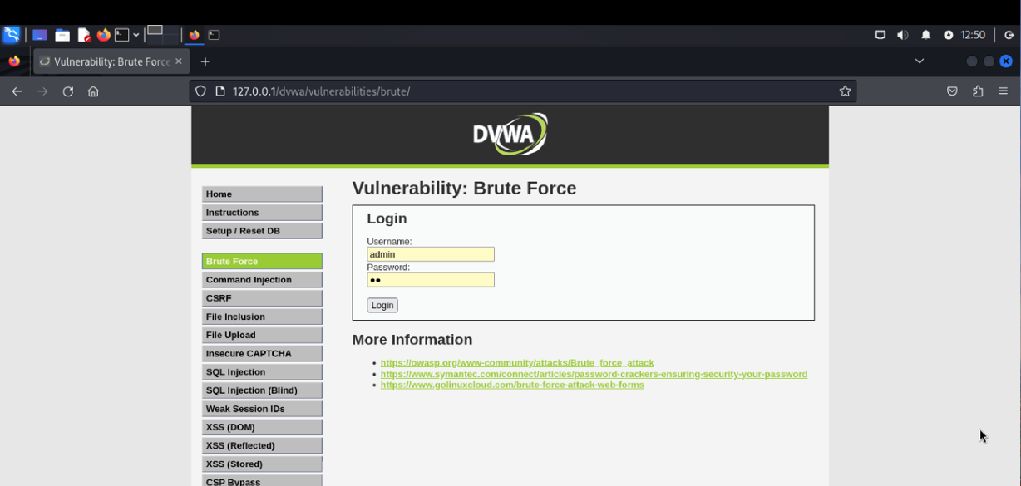

Successfully downloaded and configured Caldera on the attacker machine.

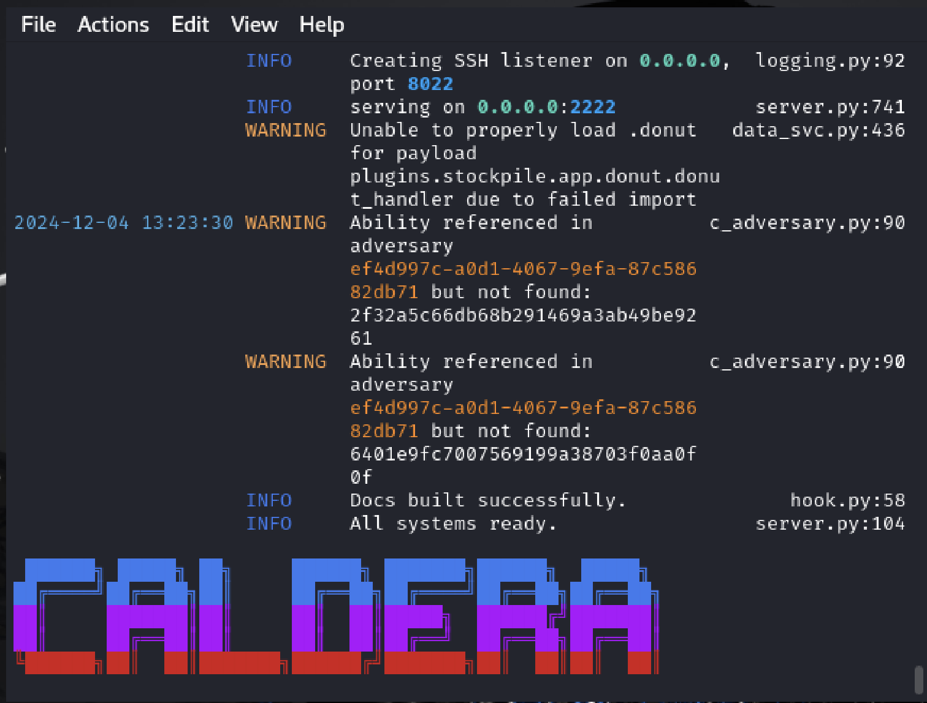

Accessing Caldera Dashboard

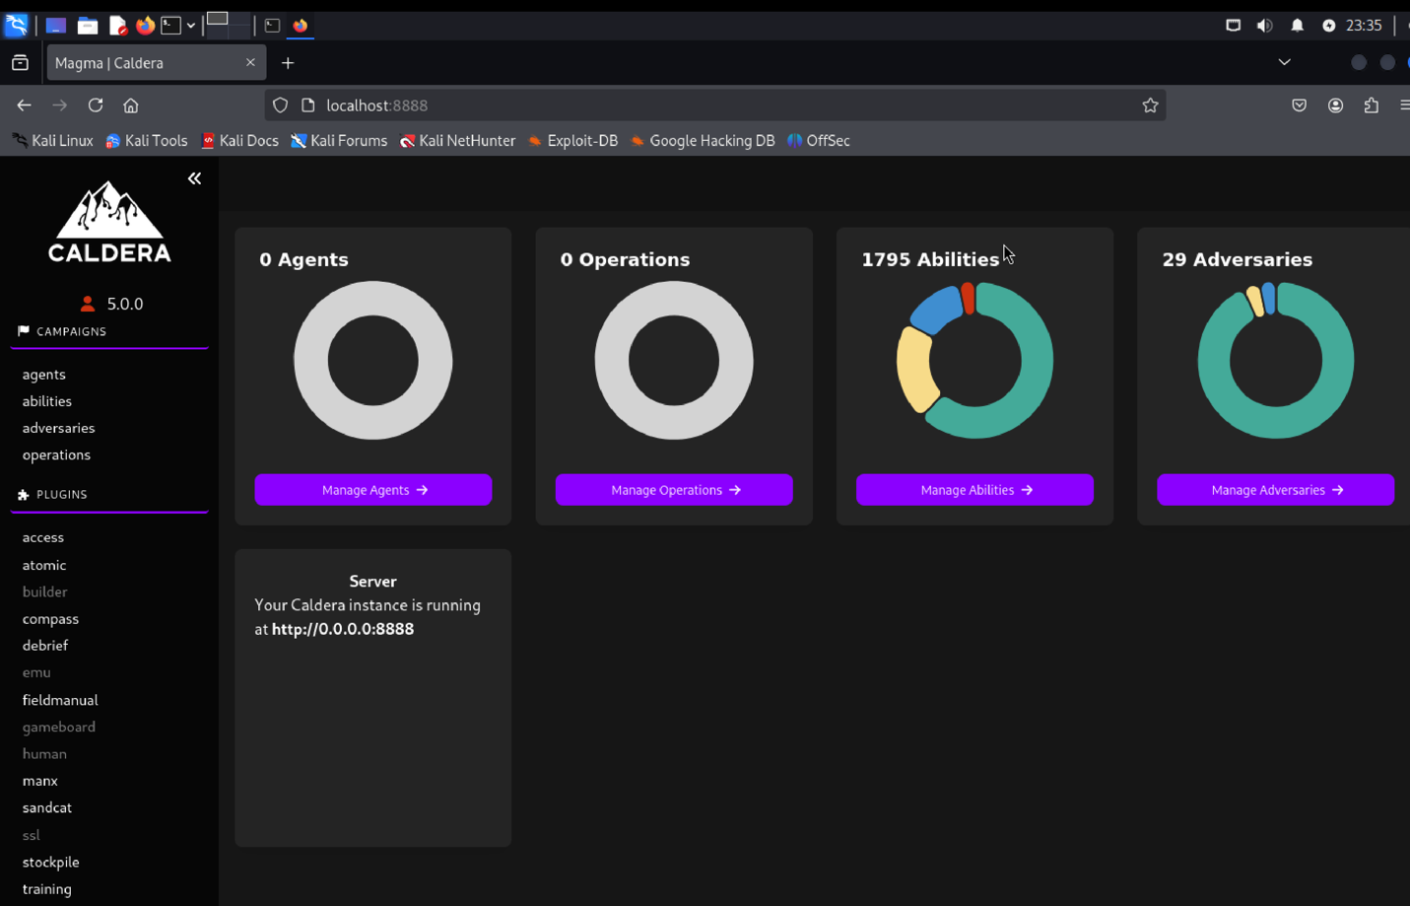

The code used to deploy the caldera agent at the victim machine.

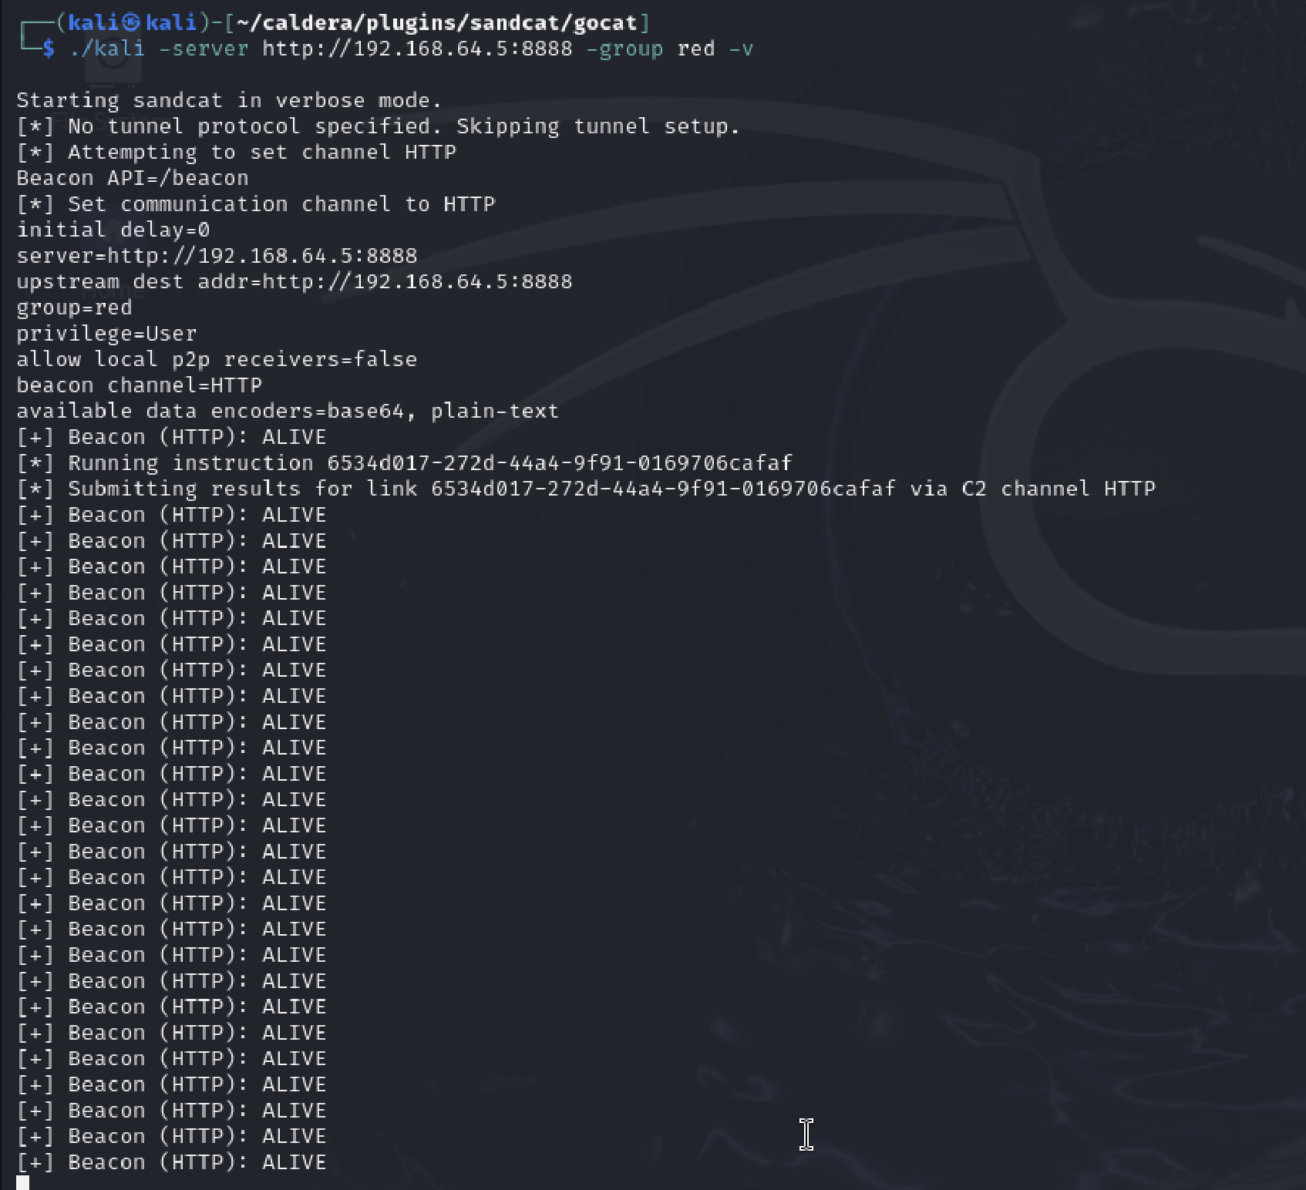

Caldera agent successfully deployed on the victim machine

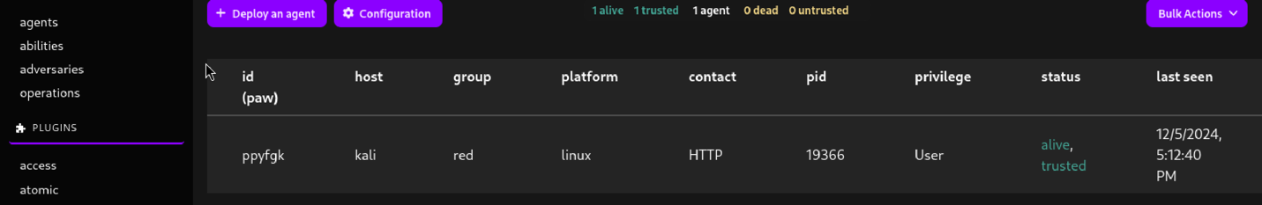

This tab allows us to see details about the agent.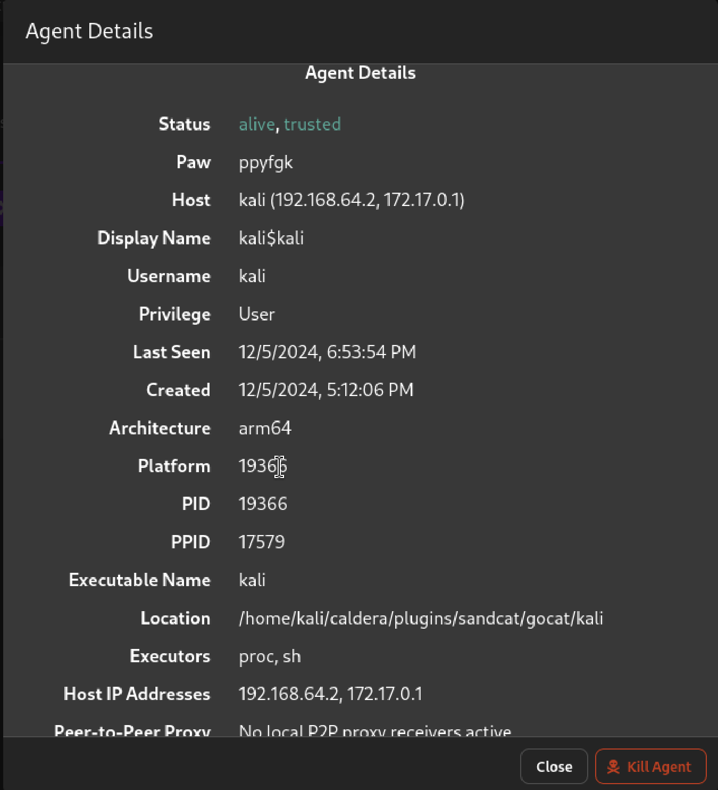

Creating a new adversary with custom abilities. 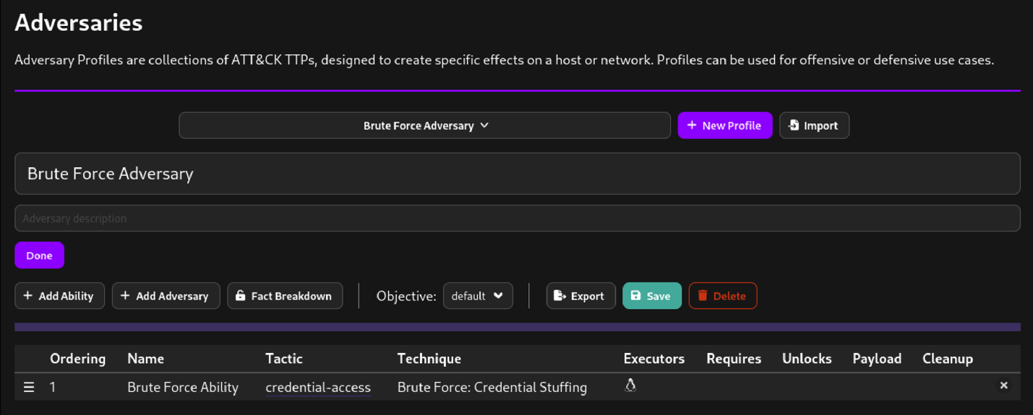

After the brute force adversay has been created, now the operation is initiated.

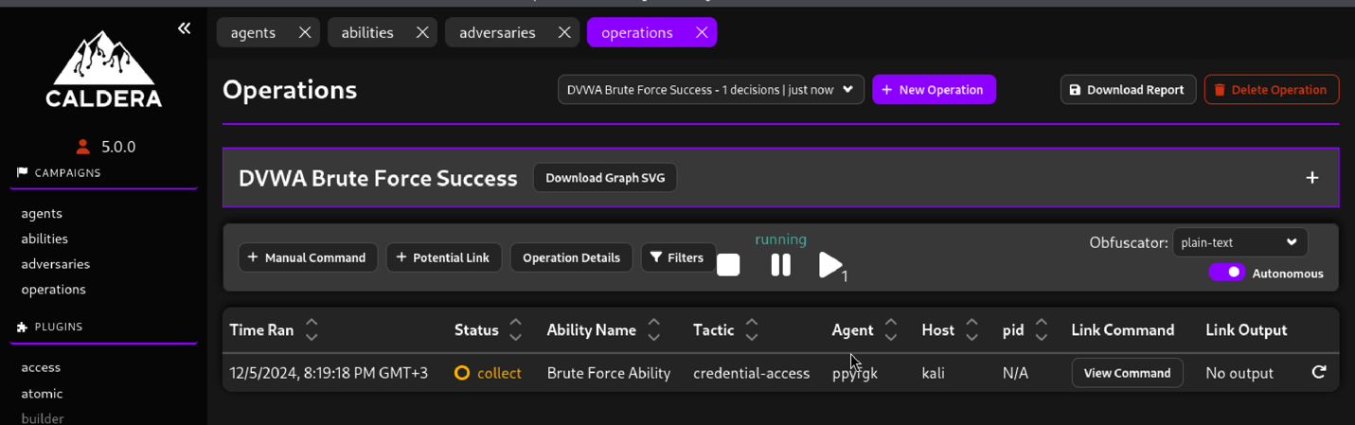

The operation was completed, and the brute force attack is successful on DVWA.

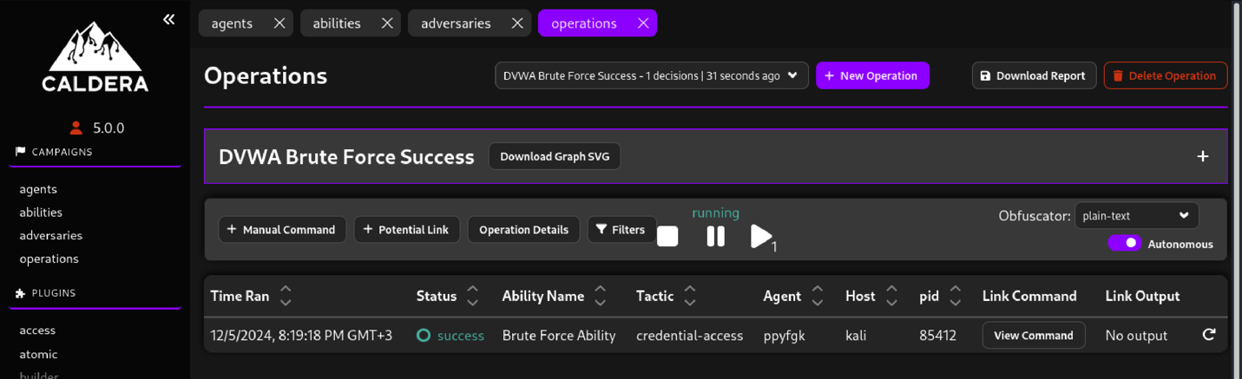

Attack attributes.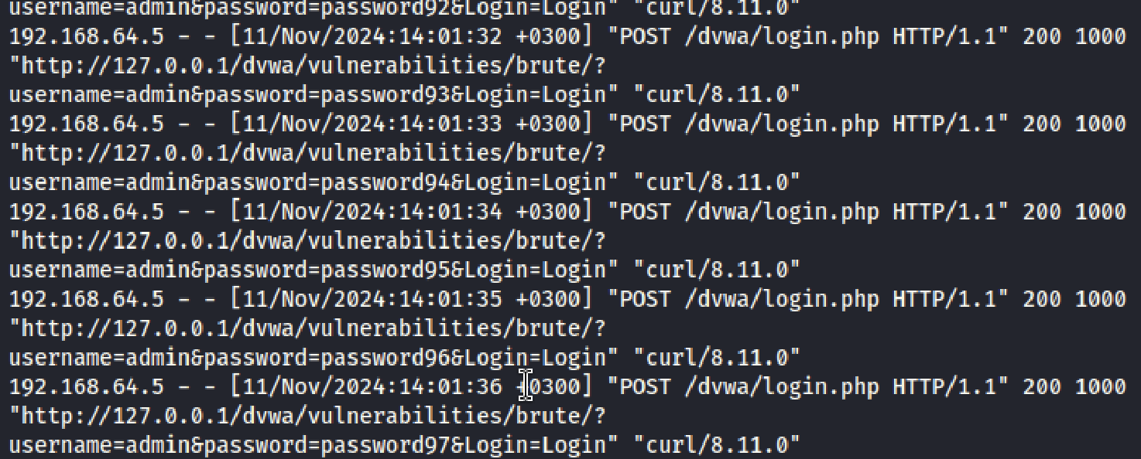

## Task 1.2 - Use Kali Linux & tools like Metasploit to compromise the service

1. IP config

* Kali IP: 192.168.8.108
* Metasploitable2 IP: 192.168.6.112

1. Initial reconnaissance on port 80 (http)

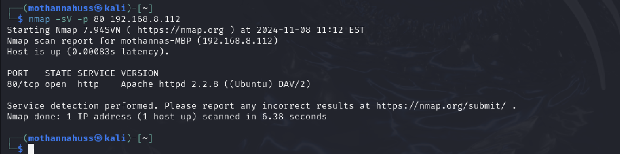

Traget service will be the apache http server

1. Directory scanner search

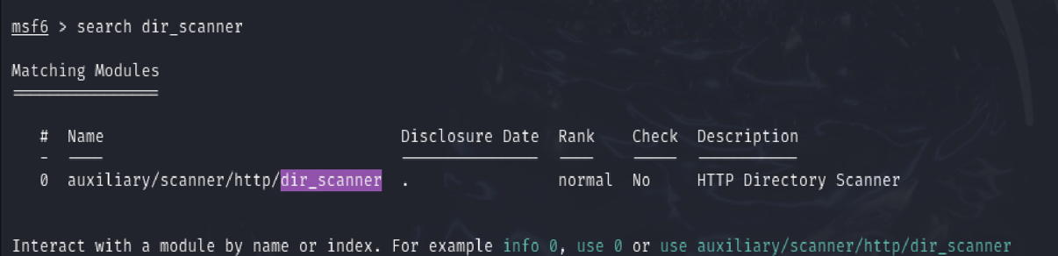

1. Target host set up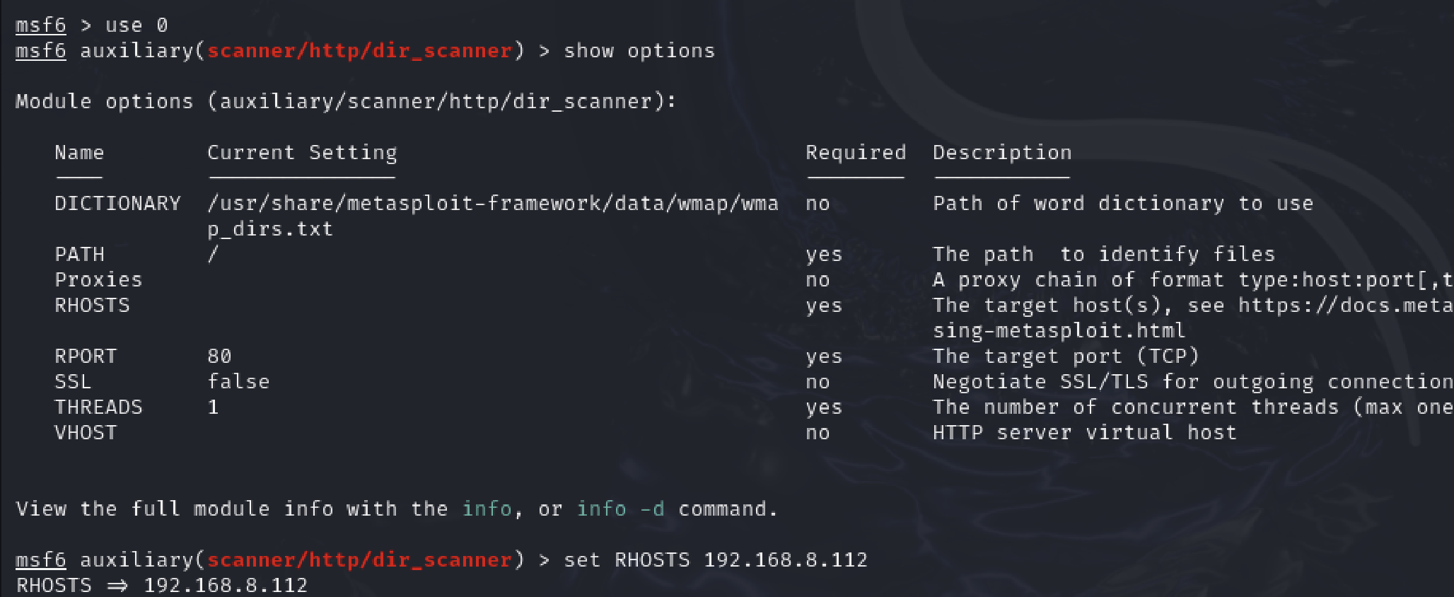
2. Directory scan on the target machine

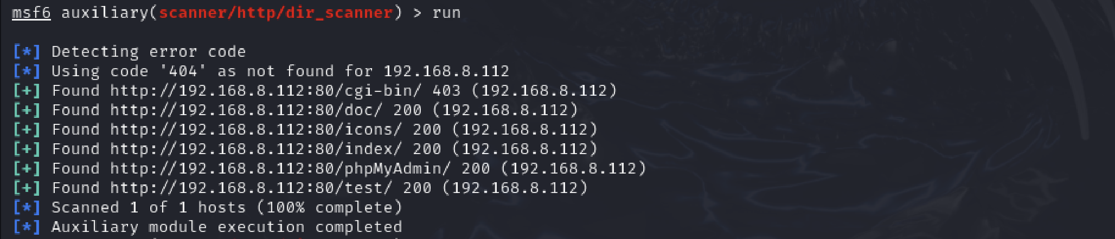

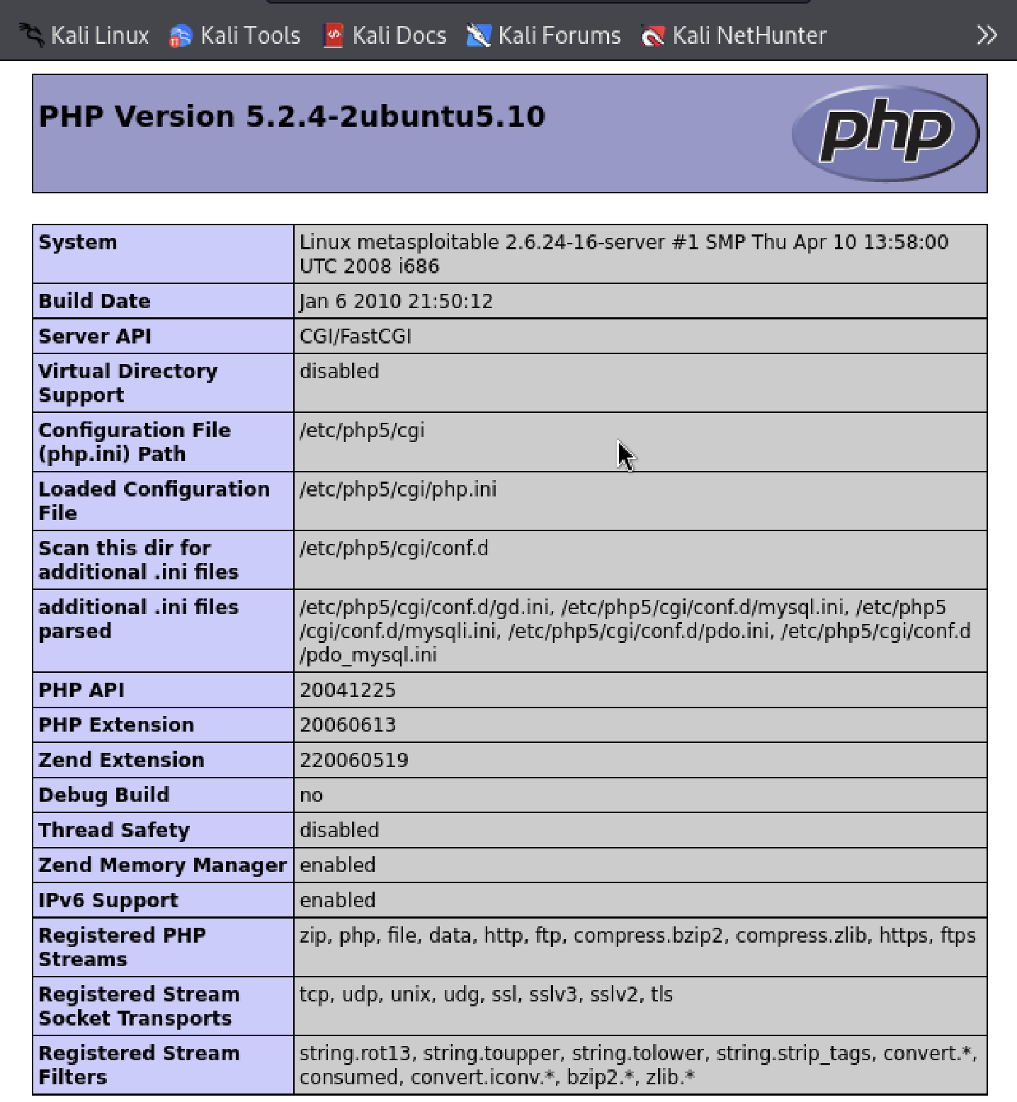

1. Search for php cgi vulnerabilities, the used exploitation in this demo is argument injection

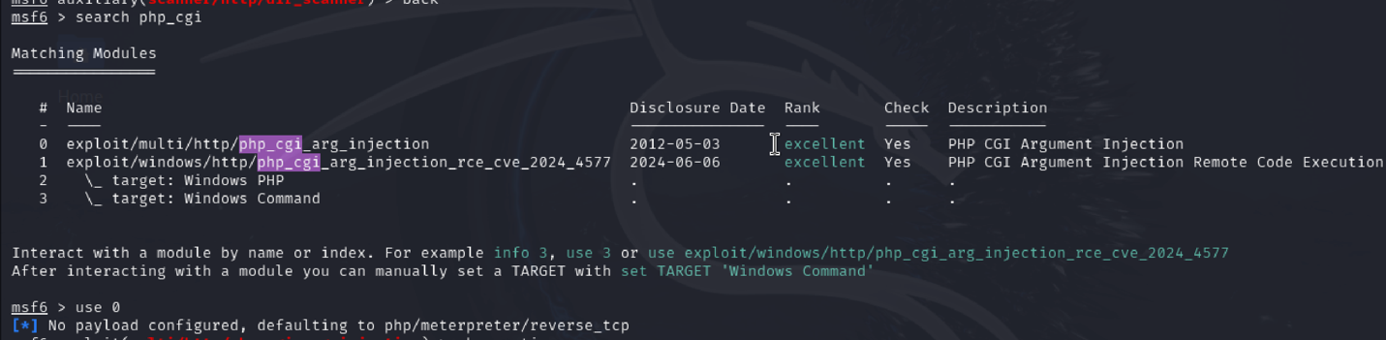

1. Setting the kali machine as the LHOST

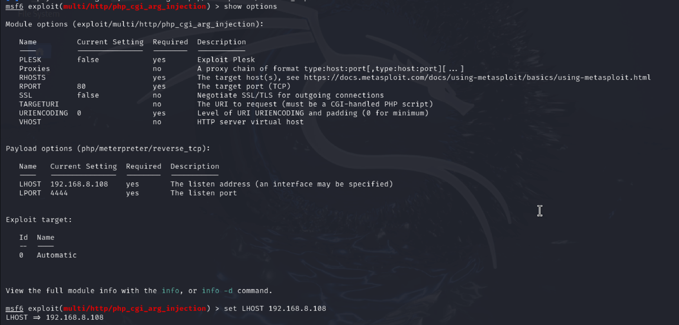

1. Set RHOST as the metasploitable machine and start exploiting

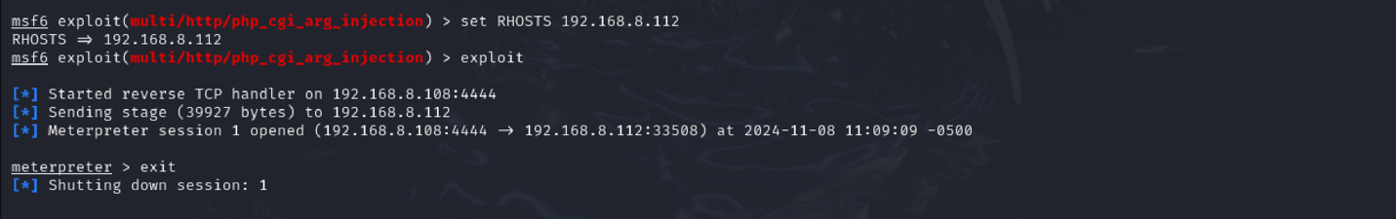

After this step we had a live Meterpreter session through which we can interact with the target system.

## Task 1.3 – The scripts/commands to compromise the service

1. IP:
   1. Kali: 10.0.2.15
   2. Metasploitable2: 192.168.134.128
2. Script: We developed the script using python (requests library)

import requests as re

base_url = "<http://192.168.134.128>"

def brute_force_directories(base_url, paths):

print("Starting directory brute-forcing...")

for path in paths:

url = f"{base_url}/{path}"

response = re.get(url)

if response.status_code == 200:

print(f"[+] Found accessible path: {url}")

else:

print(f"[-] {url} - Not accessible")

# sql Injection (T1190) Exlpoitaion

def sql_injection(base_url):

print("Testing for SQL injection vulnerability (T1190)...")

url = f"{base_url}/login"

payload = {"username": "admin'--", "password": "password"}

response = re.post(url, data=payload)

if "welcome" in response.text.lower():

print("[+] SQL Injection (T1190) successful with payload:", payload)

else:

print("[-] SQL Injection (T1190) failed.")

def brute_force_login(base_url, usernames, passwords):

print("Starting brute-force login...")

for username in usernames:

for password in passwords:

payload = {"username": username, "password": password}

response = re.post(f"{base_url}/login", data=payload)

if "weclome" in response.text.lower():

print(f"[+] Successful login: {username}:{password}")

return

else:

print(f"[-] Failed login: {username}:{password}")

# command_injection (T1059) Exploitation

def command_injection(base_url):

print("Testing for Command Injection (T1059)...")

url = f"{base_url}/exec"

payload = {"cmd": "ls; whoami"}

response = re.post(url, data=payload)

if "root" in response.text or "user" in response.text:

print("[+] Exploit: Command Injection (T1059) successful!")

else:

print("[-] Exploit: Command Injection (T1059) failed.")

paths = ["admin", "login", "test", "backup"]

usernames = ["admin", "user", "guest"]

passwords = ["12345", "password", "admin"]

brute_force_directories(base_url, paths)

sql_injection(base_url)

brute_force_login(base_url, usernames, passwords)

command_injection(base_url)

1. Results
   1. Metasploitable2:

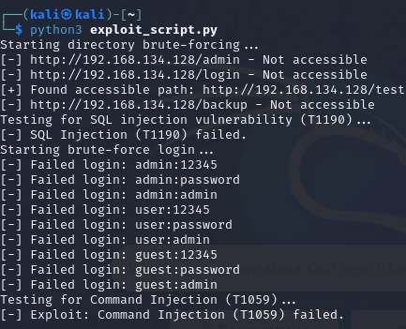

1. MITRE ATT&CK

We used different techniques

1. T1059 (Command and Scripting Interpreter): Adversaries may misuse command and script interpreters to run commands, scripts, or programs. These tools allow interaction with computer systems and are common across many platforms. Most systems include built-in command-line interfaces and scripting capabilities; for example, macOS and Linux come with a version of Unix Shell, while Windows provides Windows Command Shell and PowerShell.
2. T1190 (Exploit Public-Facing Application): Adversaries may try to exploit vulnerabilities in an internet-facing host or system to gain initial access to a network. These vulnerabilities could be caused by software bugs, temporary issues, or misconfigurations.
   * + 1. **Technical Knowledge**

Describe the technical aspects of your project setup in detail, including:

**Setup Configuration:**

* How did you configure Caldera, the honeypot, and the SIEM platform?

We used CALDERA as our red-teaming platform. Setting up CALDERA was challenging initially, primarily due to its configuration requirements and integration with the DVWA (Damn Vulnerable Web Application). However, once configured, CALDERA ran smoothly and allowed us to deploy various TTPs

* What TTPs did you select and how were they applied?

We used **T1059 - Command Line Execution** and Credential Access **T1110.001 - Brute Force Password Guessing** for DVWA, and **T1190 - Exploit Public-Facing Application** for Apache on Metasploitable 2.

* Which Kali tools and custom scripts did you use, and how were they integrated into the attack?

We used Nmap for reconnaissance, Metasploit for exploitation, and custom Python scripts (Requests library) for brute-forcing and directory scanning.

**Service Selection:**

* Which services did you target and why?

DVWA’s login page and Apache HTTP server on Metasploitable 2.

* Why did you select these specific services for this project?

**DVWA** is a safe, controlled environment for testing web vulnerabilities, also it is easy to work with. While **Metasploitable 2** is already familiar to us from HW1 and it provides various services with known vulnerabilities for practical learning.

**Challenges and Bugs:**

* What challenges or bugs did you encounter during the setup and attack execution?

The initial **Caldera** setup was complex; agent communication issues were frequent. Also, we faced some issues with Caldera’s permissions to access external files. For **Metasploitable 2** it was easy and smooth.

* How did you overcome these issues?

Absolute file paths were implemented to ensure Caldera could access the necessary files.

**Best Practices and Recommendations:**

Based on your experience, what best practices would you recommend for future students working on a similar project?

Document every step, use virtual networks for isolation, and apply incremental testing to identify issues early. Especially while dealing with Caldera. And start as early as possible. Documenting every step will help you communicate progress with your team and also save you time while answering these questions.

**Project Feedback:**

* How much did you learn from this project? Provide a brief reflection on your experience?

This project provided hands-on experience with offensive tools and techniques, improving our understanding of real-world vulnerabilities. Also, to be honest it mostly tested our problem-solving, communication, and teamwork skills as we had to use them to deal with Caldera.

* Do you recommend this project for use in future course cycles?

**Yes**, this project is beneficial for future cycles as it reinforces practical security skills.

**Learning Resources:**

* What learning resources did you rely on during the project?

**YouTube** tutorials for tool setup, **Caldera** and **Metasploit** **documentation**, and some of the sources provided by you.

* Specify the exact platforms or materials you used, such as edX, Coursera, YouTube, official documentation, or other relevant sources.

YouTube, Caldera, and Metasploit documentation

* + - 1. **Attack Details**

**Effectiveness and Success Rate:**

* Which tool/approach was most effective at compromising the service?

Metasploit was highly effective for exploitation, especially with Apache vulnerabilities. And Python script using the Requests library was the most interesting one.

* Were there any limitations in one method that other methods overcame?

**CALDERA’s** automation lacked flexibility for some specific attacks achievable with custom scripts.

* How successful were you in replicating a real-world attack scenario?

Overall, we successfully replicated common attack scenarios, especially in password guessing and command injection

**Ease of Use and Automation:**

* How easy or difficult was it to use Caldera compared to Kali tools and manual scripting?

**Kali** tools and **manual scripting** were more intuitive and allowed for direct control compared to **CALDERA**, which required heavy configuration.

* How did the level of automation in Caldera affect the overall process?

CALDERA’s automation streamlined repetitive tasks, improving process efficiency.

* Which approach required the most manual intervention or expertise?

Custom scripts required the most manual input and adjustments. But it was more fun and interesting.

**Time and Effort:**

* Which task took the least/most time to execute?

Scanning with Nmap was the fastest. And, The brute-force attack using Caldera required the most time.

* How does automation (Caldera) compare with manual efforts in terms of efficiency?

CALDERA saved time on repetitive tasks, while custom scripts demanded more effort and debugging. However, in terms of setup Caldera was a nightmare.

* Did the use of custom scripts require significant debugging or trial-and-error?

Required extensive trial-and-error, particularly for directory brute-forcing.

**Learning Curve and Skill Requirements:**

* Which approach was the easiest to learn and apply?

Kali tools, especially Nmap and Metasploit, were relatively straightforward.

* How did previous experience (e.g., with Kali or scripting) impact the outcomes?

Familiarity with Kali accelerated understanding; scripting required more reviewing of Python since it has been some time since we used it.

* What new skills or insights did each task provide?

Gained practical skills in Python scripting for brute-force attacks and directory scanning.

**Flexibility and Creativity:**

* How flexible were Caldera and Kali tools in supporting creative/novel techniques?

Custom scripts provided more adaptability than pre-built CALDERA or Metasploit modules.

* Were there limitations in using pre-built tools that custom scripting could overcome?

Pre-configured tools couldn’t accommodate unique payloads or novel TTPs.

* How did your novel TTPs compare to the predefined MITRE ATT&CK techniques?

Custom scripts allowed for more creativity and were closer to real-world adversary techniques. It aligned with MITRE’s Credential Access and Execution techniques and provided additional flexibility.

**Detection and Stealth:**

* Which approach was most likely to bypass detection mechanisms?

**CALDERA** was less noisy due to its gradual automation.

* How easily would each method be detected by a SIEM or honeypot?

**Metasploit** was likely the noisiest and most easily detectable. (Waiting for Phase 2)

* Were certain methods noisier or stealthier than others?

**Manual scripting** and brute-force attacks generated noticeable traffic.

**Alignment with MITRE ATT&CK Framework:**

* How well did each approach map to the MITRE ATT&CK TTPs?

All tools mapped well to T1059 (Command Execution) and T1110.001 (Password Guessing).

* Were there any gaps or deviations in existing tools when compared to the desired TTPs?

Pre-built tools sometimes lacked flexibility for unique attack paths.

* How did developing your own TTP contribute to a better understanding of adversary behavior?

Developing custom scripts deepened our understanding of TTPs. It provided us with a good understanding of how attackers configure their techniques to avoid detection.

**Impact on the Target System:**

* Which approach caused the most/least disruption to the service?

**Metasploit**’s aggressive scans caused slight instability in the target.

* Were any unintended consequences (e.g., service crash, instability) observed?

None severe, but heavy scans affected performance temporarily.

**Future Application and Improvement:**

* Which method would you recommend for a future red-teaming engagement and why?

**Metasploit** and **custom scripts**, due to their effectiveness and adaptability.

* What could be improved in each approach to make it more effective or efficient?

**CALDERA:**

**Improve**: Add more flexible options for different attack types.

**Make Efficient**: Include automated scanning to speed up recon.

**Kali Tools (Nmap, Metasploit):**

* **Improve**: Use more precise settings to reduce unnecessary scans.
* **Make Efficient**: Automate repeated tasks with scripts.

**Custom Scripts:**

* **Improve**: Add better error handling and clear logging.
* **Make Efficient**: Use multi-threading to speed up tasks like brute-forcing

# Phase 2

**Task 1.1**: Compromise the service using Caldera (an automated red-teaming framework).

Honeypot setup

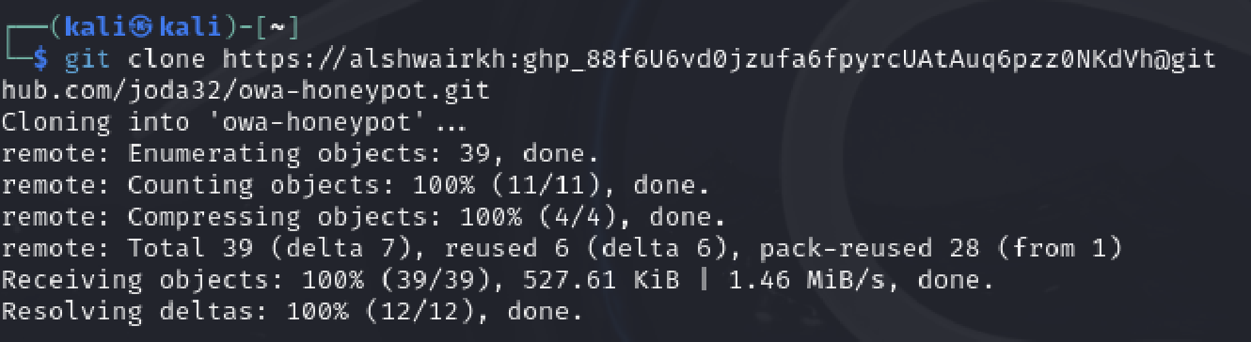

Successfully set up the honeypot in the victim machine.

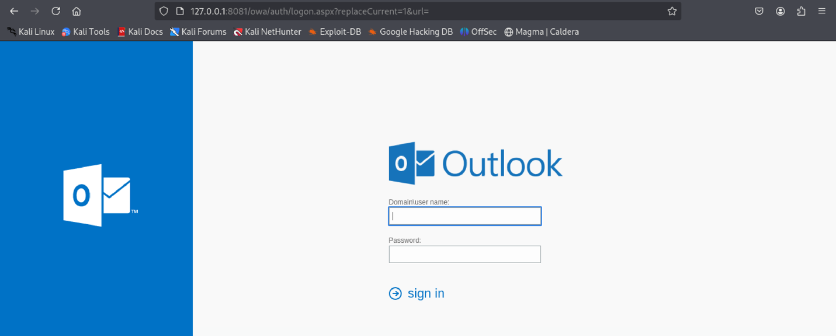

Creating a new profile for the owa brute force attack

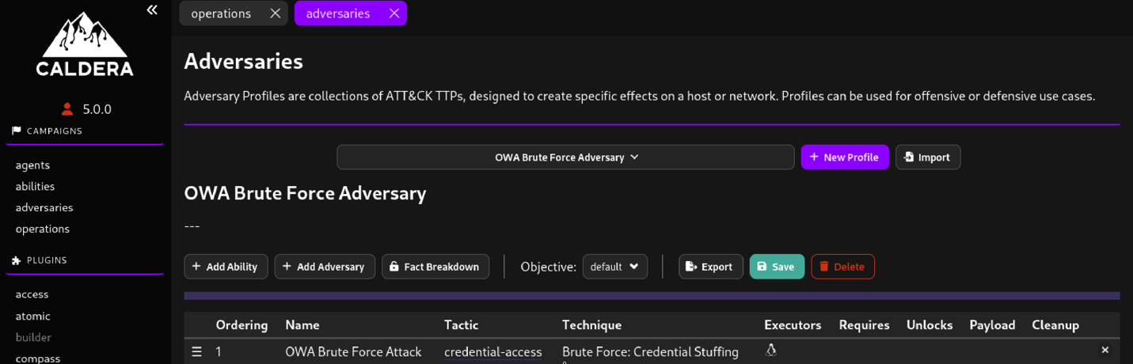

Operation performed successfully on owa honeypot but didn’t crack the password.

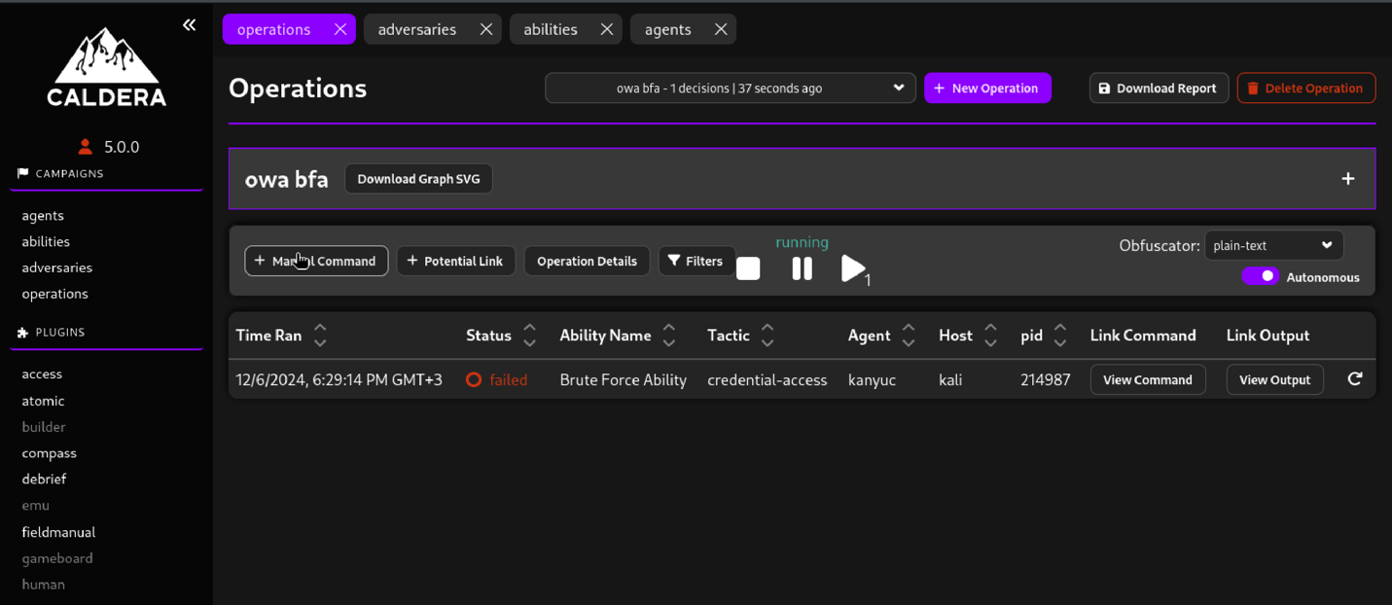

Attack logs

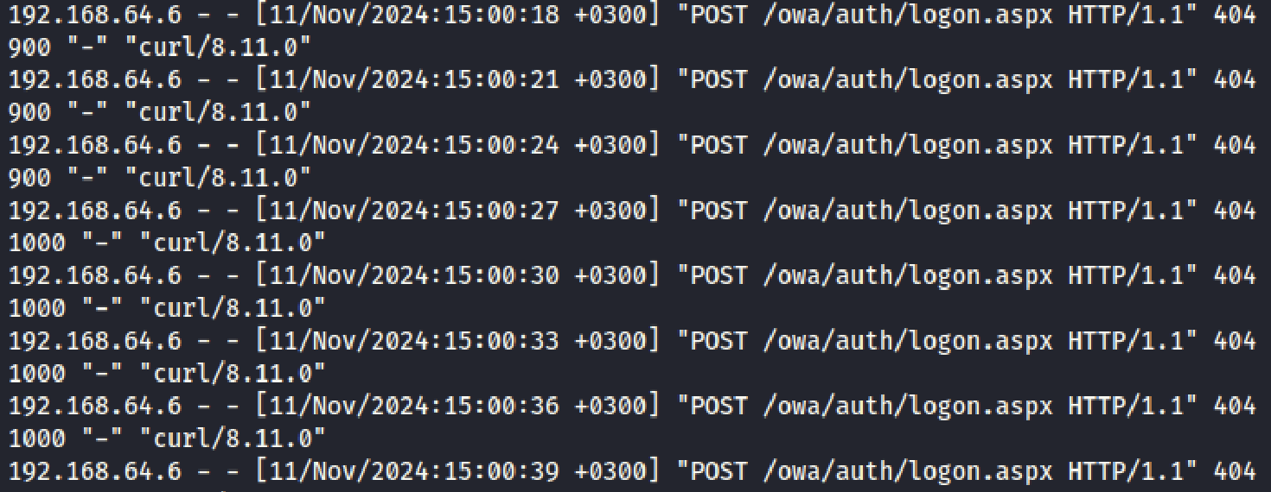

**Task 1.2**: Use Kali Linux and tools like Metasploit to compromise the service.

This task was conducted using metasploit in Kali Linux.

**Honeypot’s server IP and Port:**

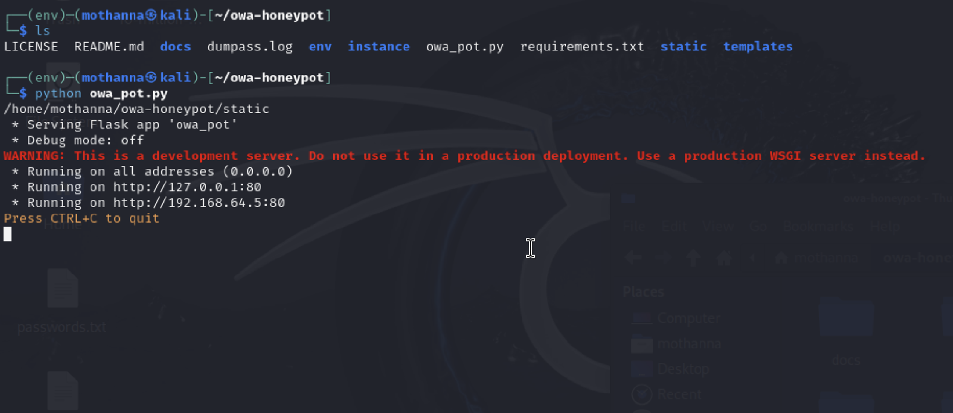

**Available owa http exploits:**

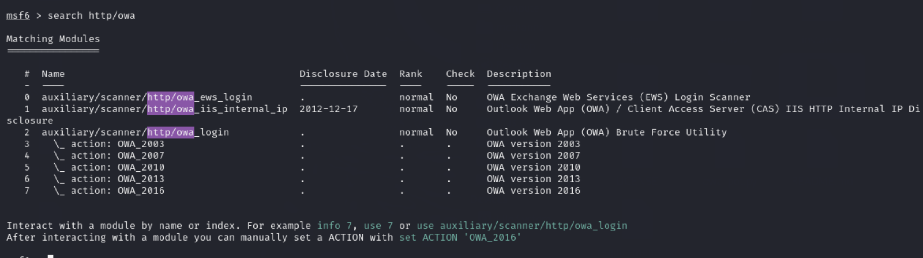

**Directory scanning exploits:**

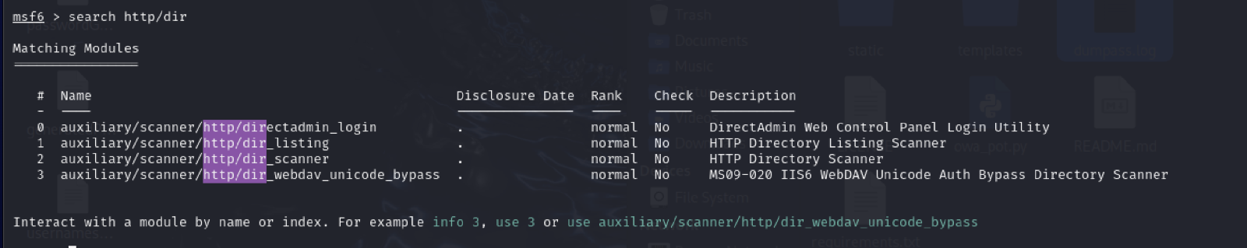

**Metasploit password attack configuration:**

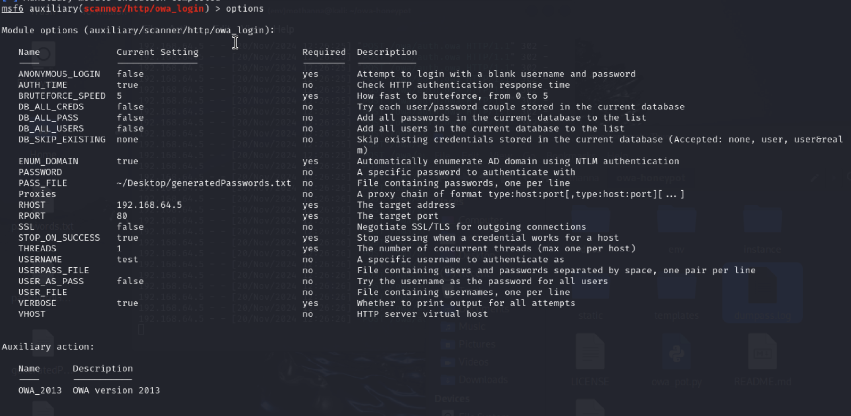To perform the task, owa_login scanner was employed to launch a password attack on the honeypot’s server with the options illustrated in the image above.

The passwords used to conduct the attack were collected from this [dataset.](https://github.com/danielmiessler/SecLists/blob/master/Passwords/Common-Credentials/10-million-password-list-top-1000000.txt) A subset of the dataset was used with a total of 10 thousand unique passwords.

**Directory scanner configuration:**

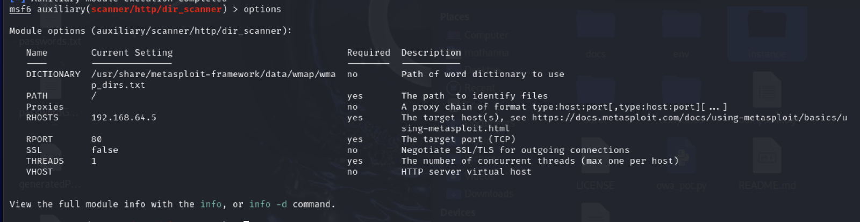

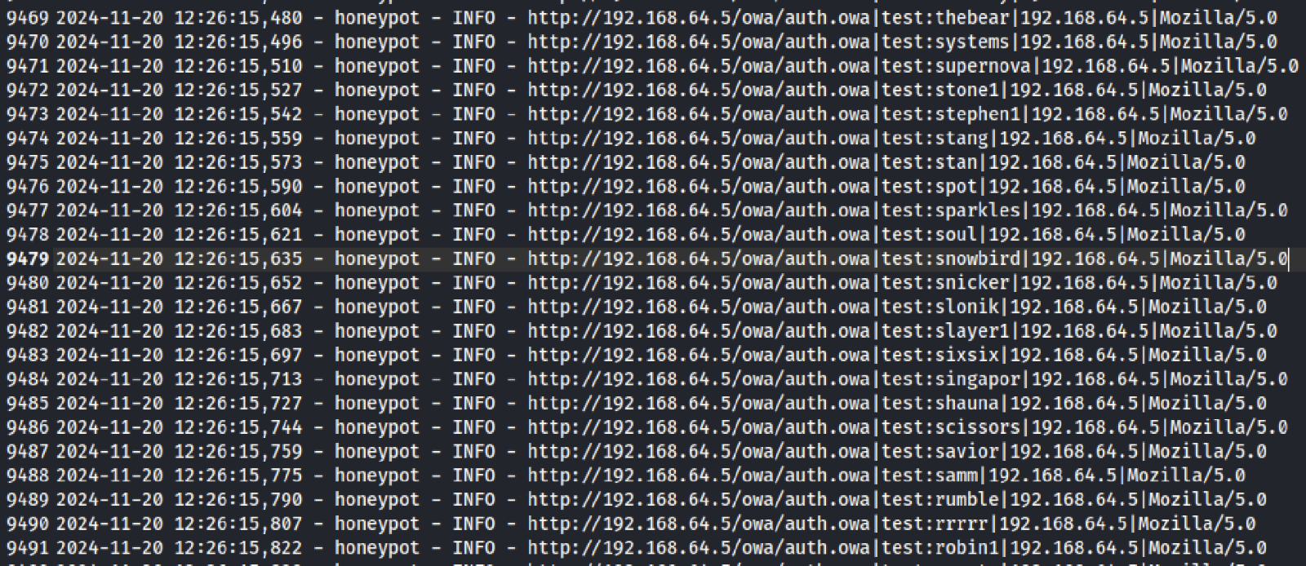Subset of the logs generated from the honeypot’s server side. Those logs illustrate the attempts made by the attack break into the server, which can be further analyzed by cyber defense teams to mitigate future attacks.

**Scanning results:**

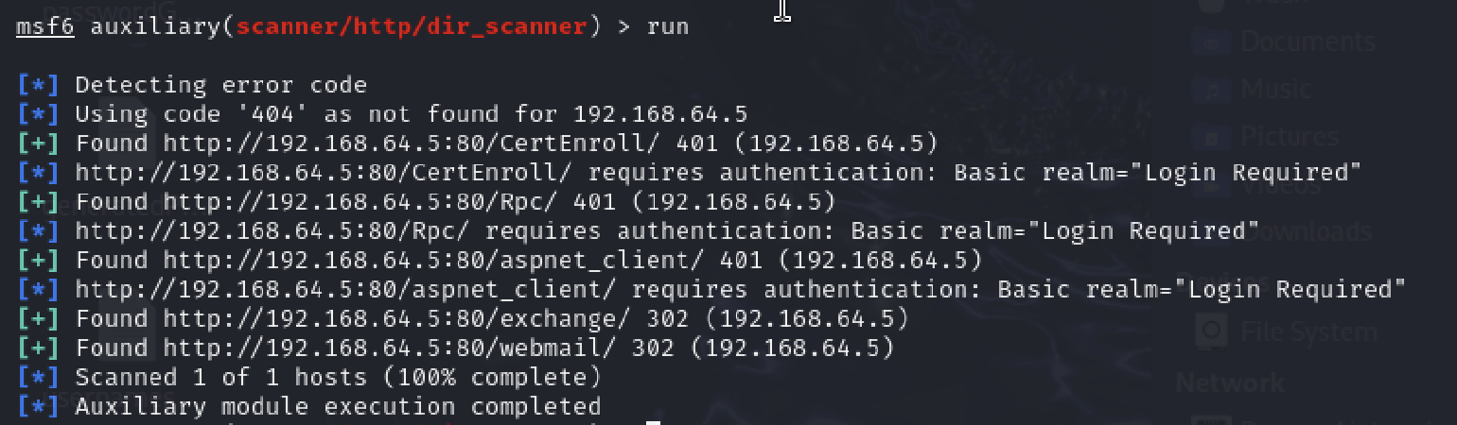The directory scanning output from Metasploit's dir_scanner module identified several accessible directories on the honeypot, including /CertEnroll/, /Rpc/, and /aspnet_client/. These directories returned a 401 Unauthorized status, indicating they require authentication for access. Additionally, directories such as /exchange/ and /webmail/ returned a 302 Redirect, suggesting they lead to other endpoints, likely login forms. The scan confirms that the honeypot effectively simulates protected and redirecting web application behavior, enhancing its realism for security testing.

**Task 1.3**: Write your own scripts/commands to compromise the service (on the honeypot)

* **Running the Honeypot:**

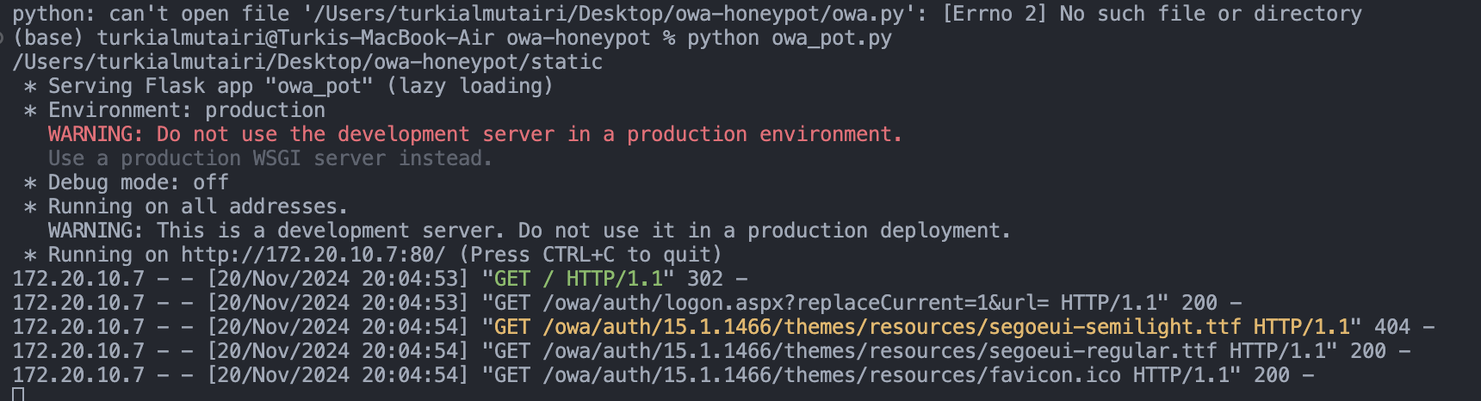

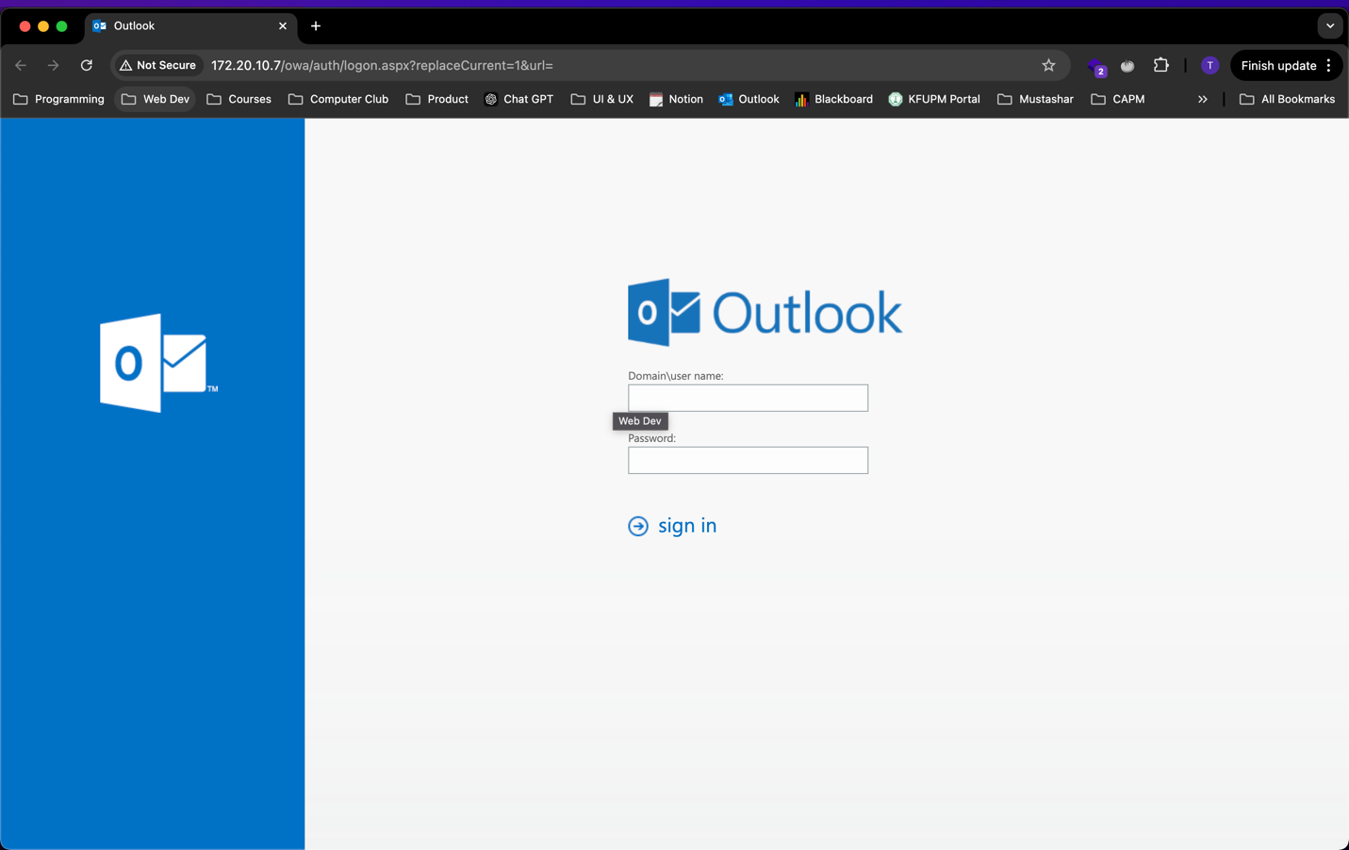

* **Brute-Force Login (T1110.001 - Password Guessing)**
  + **Objective**: Test the /owa/auth.owa endpoint by attempting to brute-force login credentials.
  + **Code**:

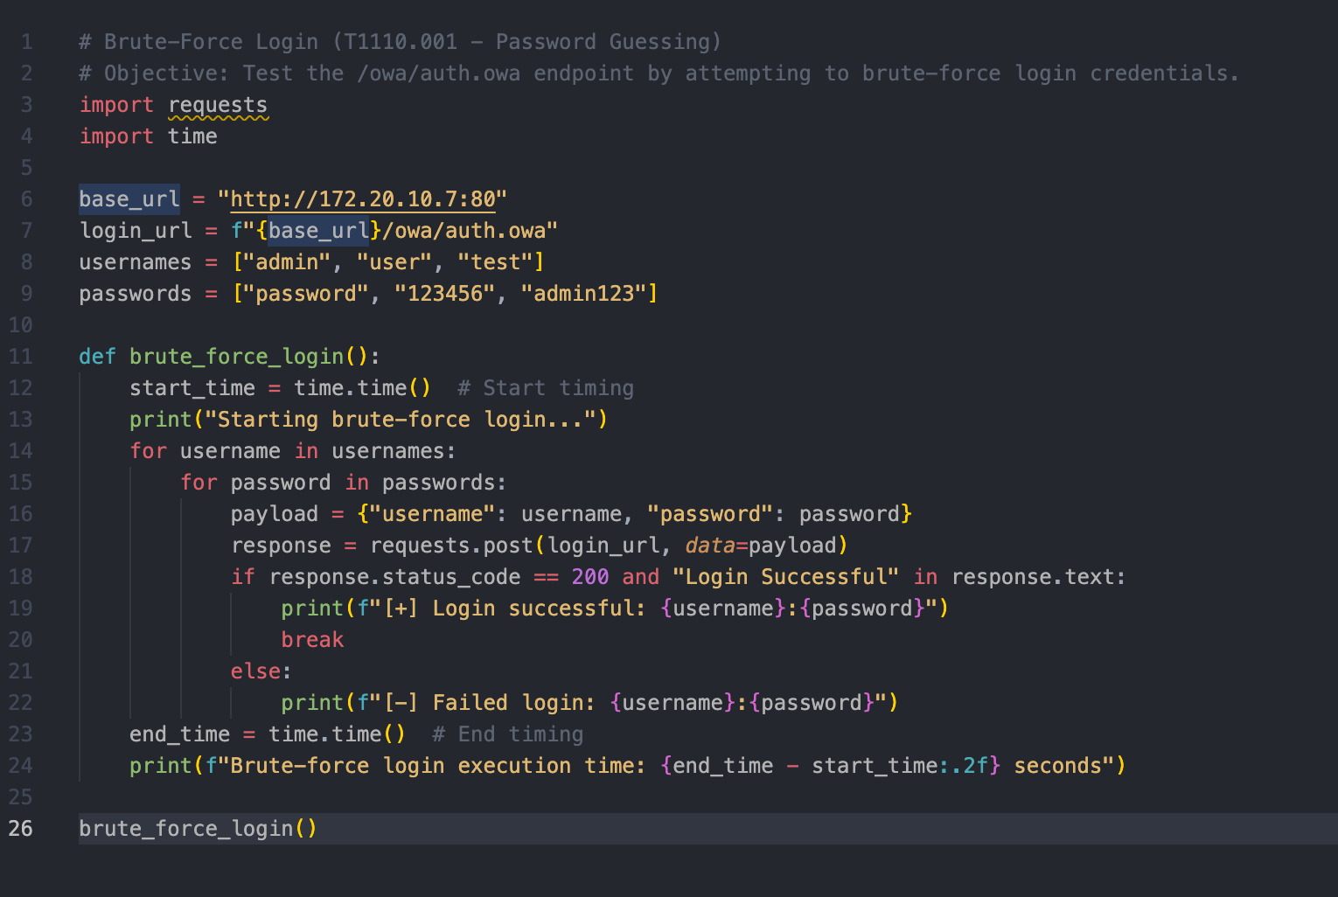

* + **Results**:

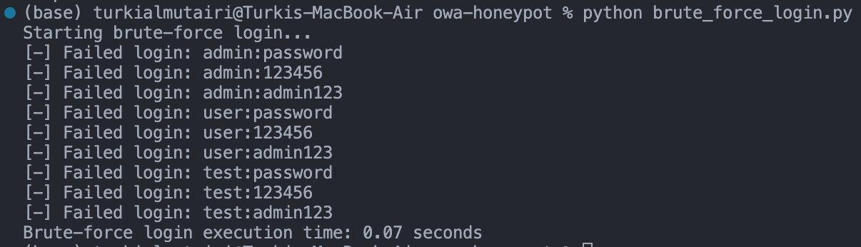

* **Directory Brute-Forcing (T1190 - Exploit Public-Facing Application)**
  + **Objective**: Discover accessible or restricted directories in the honeypot by brute-forcing common paths.
  + **Code:**

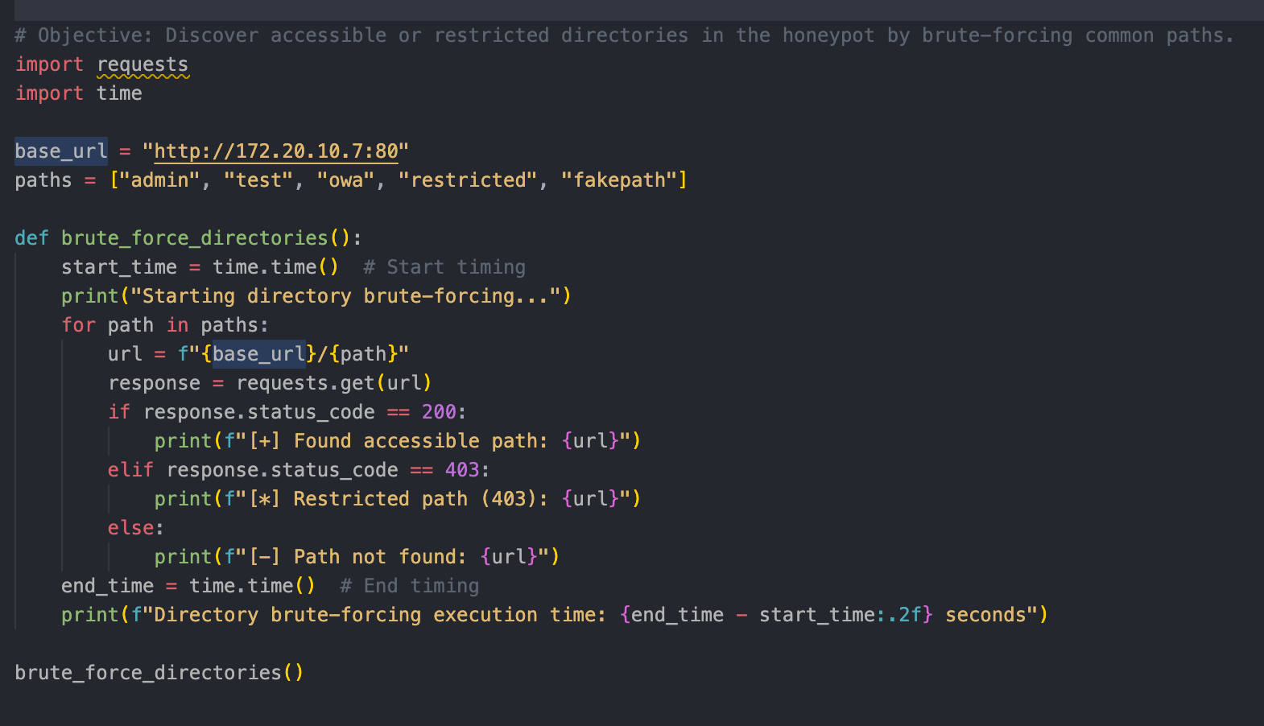

* + **Results**:

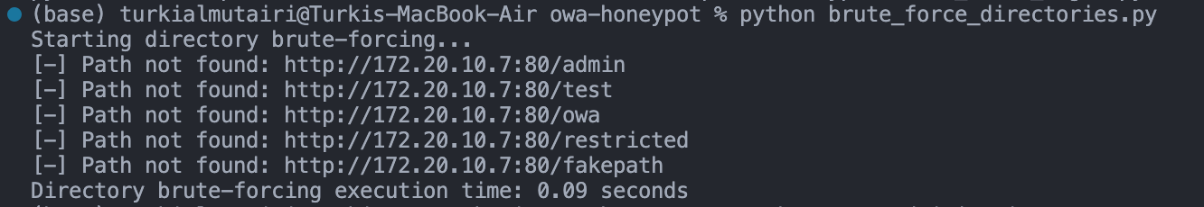

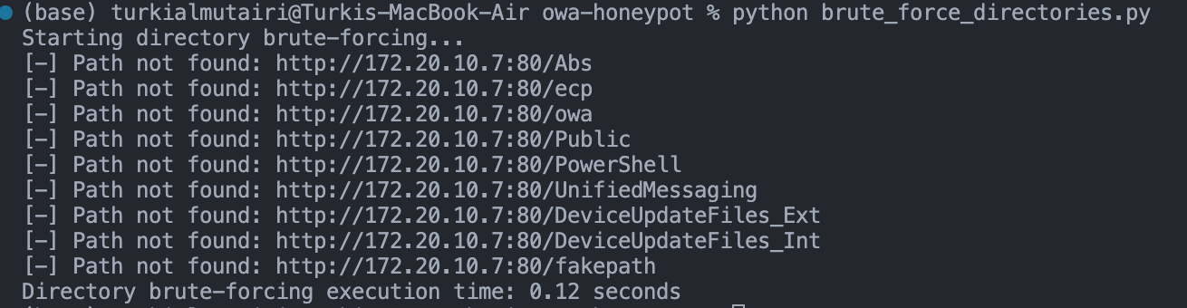

* **Command Injection (T1059 - Command and Scripting Interpreter)**
  + **Objective**: Exploit a simulated command injection vulnerability on /owa/vulnerable.
  + **Code**:

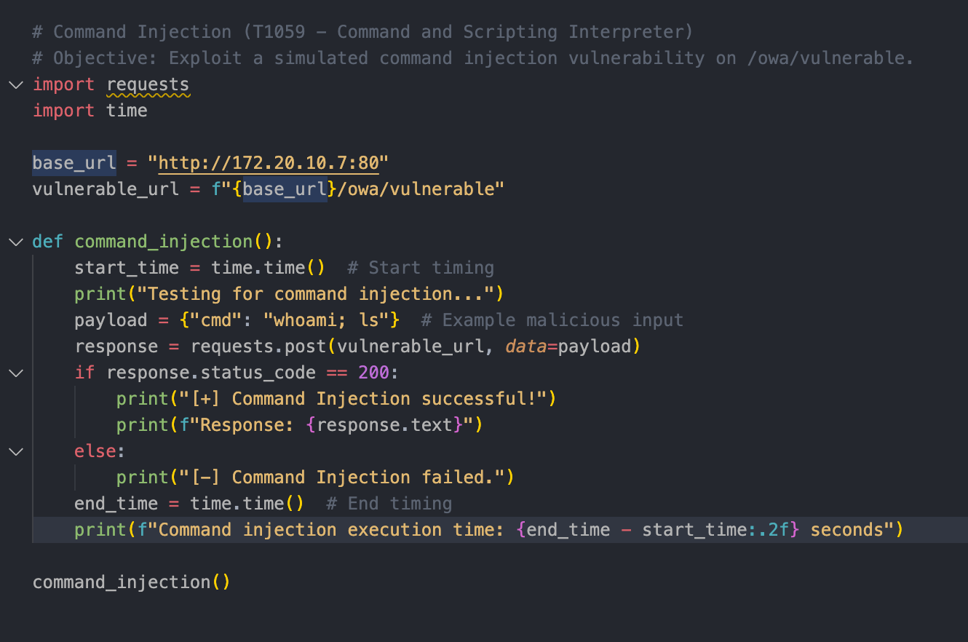

* + **Results**:



* **Custom TTP: Password Spray**
  + **Description: Simulates a "password spraying" attack across multiple accounts, using a single password per account to evade detection mechanisms**
  + **Code:**

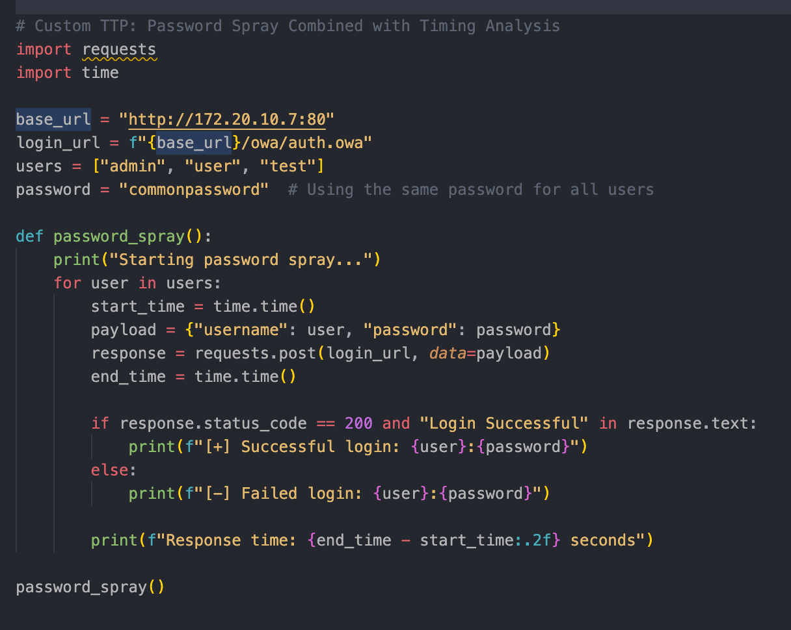

* + **Results**:

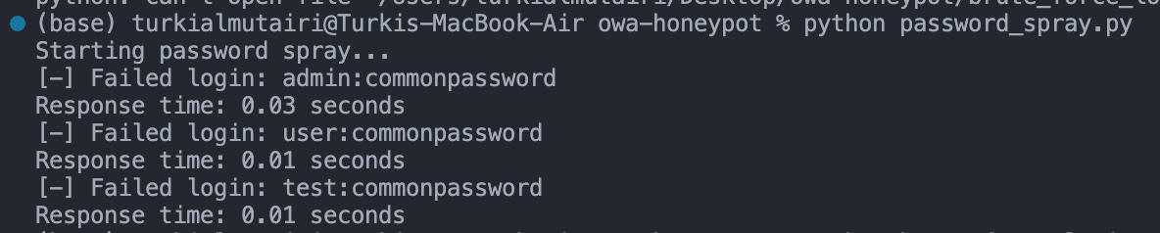

* **Execution Times:**
  + **Brute-Force Login: 0.07** seconds
  + **Directory Scanning: 0.09 – 0.12** seconds
  + **Command Injection: 0.07** seconds
  + **Password Spray: 0.03** seconds per request
* **CPU Usage & Memory Usage:**
  + **Brute-Force Login:**
    - CPU usage **increased** from **2%** to **10%**
    - Memory usage **increased** by **50MB**
  + **Directory Scanning:**
    - CPU usage **increased** from **2%** to **12%**
    - Memory usage **increased** by **40MB**
  + **Command Injection:** 
    - CPU usage **remained stable** at **5%**
    - Memory usage **increased** by **20MB**
* **Evaluation:** **How closely does it mimic the actual service?**

|  |  |  |  |
| --- | --- | --- | --- |
| **Feature** | **Honeypot Behavior** | **Actual Service Behavior** | **Realism Level** |
| Login Response | Logs credentials, no success by default | Validates credentials, allows access | **Moderate** |
| Directory Simulation | Static predefined paths | Dynamic based on real directories | **Moderate** |
| Command Injection | Requires manual addition | May execute commands if vulnerable | **Low** |
| Credential Logging | Captures all credentials submitted | Typically logs only failed attempts | **High** |
| Payload Logging | Captures and stores all payloads | Rarely logs payloads without tools | **High** |
| IP/User-Agent Logs | Captures attacker's metadata | Requires monitoring tools | **High** |
| Login UI | Basic HTML login page | Dynamic, functional UI | **Moderate** |
| Interactivity | Static interface | Fully interactive | **Low** |
| Command Injection | Requires manual addition | May execute commands if vulnerable | **Low** |
| SQL Injection | Not present | May allow injection on vulnerable fields | **Low** |
| Path Traversal | Not present | May allow traversal with crafted input | **Low** |
| Response Speed | Very fast, static responses | Slower, depends on backend processing | **Moderate** |

* **Overall and General Assessment (Summary table):**

|  |  |  |
| --- | --- | --- |
| **Aspect** | **Realism level** | **Notes** |
| HTTP Responses | Moderate | Predefined responses are somewhat realistic, but no dynamic behavior. |
| Logging and Attack Detection | High | Superior logging of credentials and payloads compared to real services. |
| User Interface | Moderate | UI mimics OWA but lacks interactivity or advanced functionality. |
| Simulated Vulnerabilities | Low | No actual vulnerabilities; requires customization to simulate attacks. |
| Response Times | Moderate | Faster than a real service, potentially unrealistic. |

# **Phase 3**

## **SIEM Analysis and findings from Kali attack on the honeypot**

We conducted a password crack attack on the honeypot with Metasploit. The attack’s methodology and steps are mentioned on the previous two phases’ sections above. Visuals and analysis of the attack are discussed in the following sections.

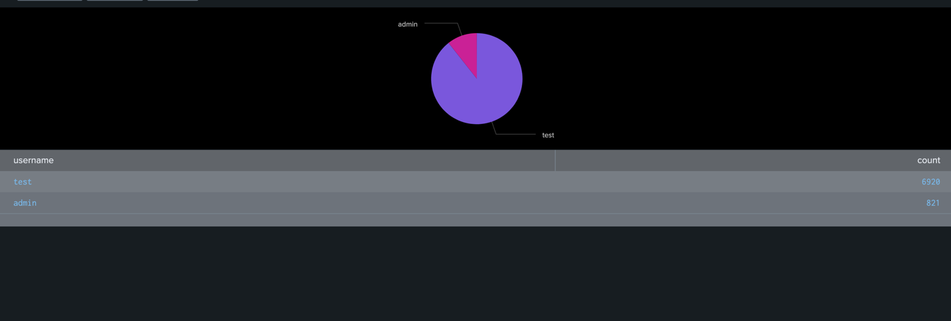

The figure listed above illustrates the most used usernames in the attack, we can see that the majority of the attack’s attempts were conducted with the username admin with a total of 6920 attempts while other attempts used test. This figure highlights that the admin account is in significant danger by attackers and needs to be secure to the most.

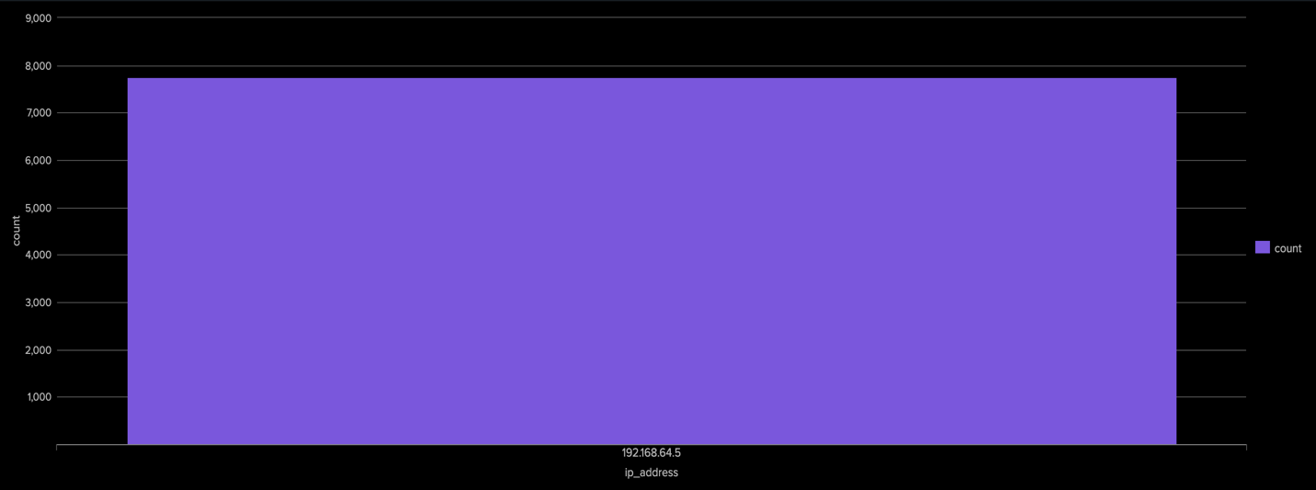

This figure illustrates which ip addresses conducted the attacks on the honeypot, the figure shows that the ip 192.168.64.5 was the one and only attacker with a around 8,000 login attempts.

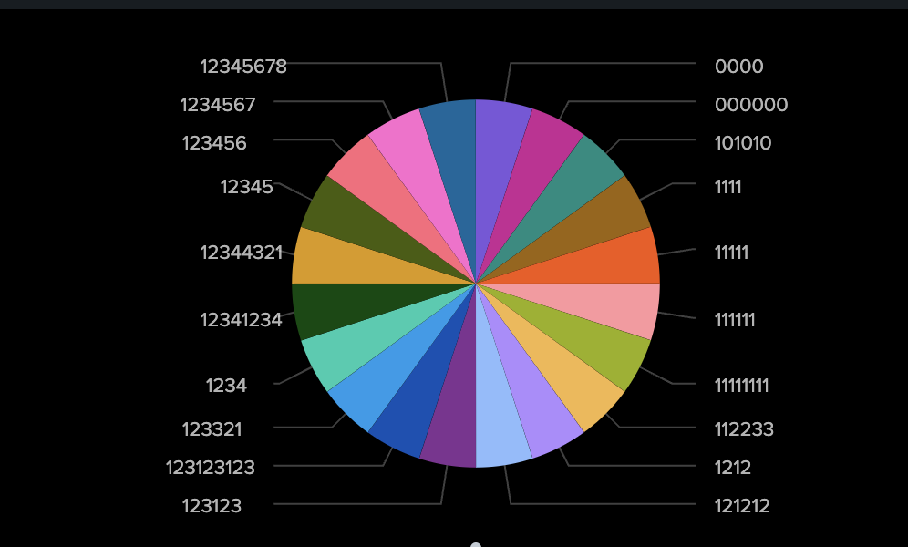

Here, we can see the top 20 most used passwords across all login attempts. All 20 passwords are equally used according to the pie chart. Noting those passwords is highly important for further protection as they are employed by attackers.

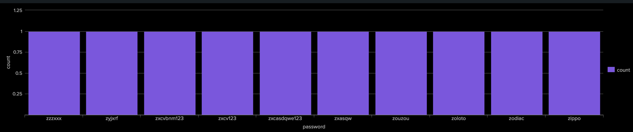

The figure above shows the least used passwords, which also indicates that the administrator needs to be aware of them and strengthen their passwords with more complex values for further protection.

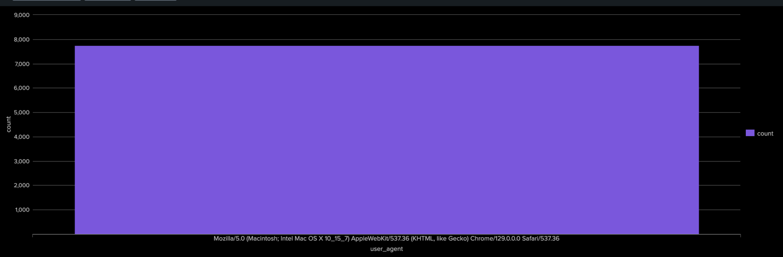

Here, this bar chart indicates that **Mozilla/5.0 (Macintosh; Intel Mac OS X 10_15_7) AppleWebKit/537.36 (KHTML, like Gecko) Chrome/129.0.0.0 Safari/537.36** is the one and only used user agent in the attack with around 8K attempts. This means that even though the user agent looks legitimate, the significant number of attempts indicates that the attack was conducted with an automated tool.

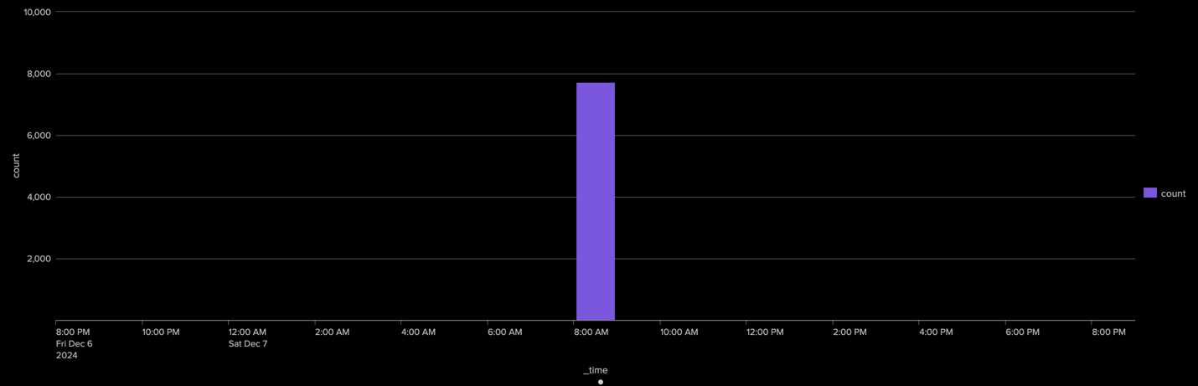

The bar chart above shows the timespan when the attack took place, we can see that the whole attack took place during the morning, precisely 8 AM with around 8K attempts.

## **SIEM Analysis and findings from Caldera’s on the honeypot**

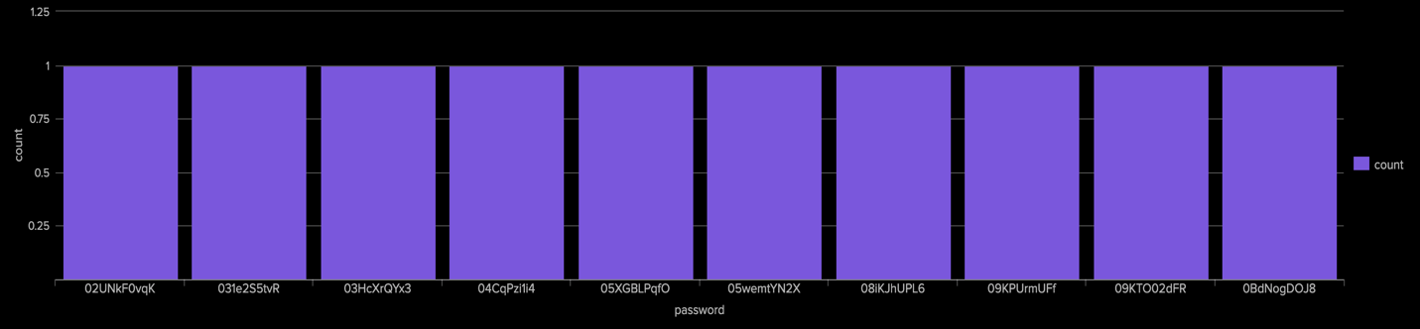

This figure shows the top 10 used passwords throughout the attack, from the figure we can conclude that all passwords used during the attack were unique.

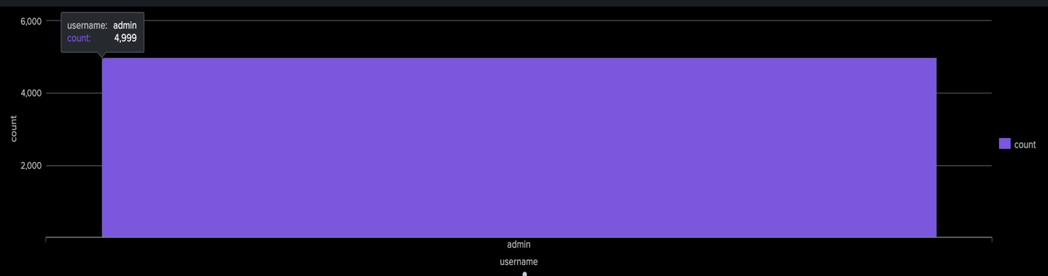

Here, this bar chart shows the usernames used by the attacker, the attack consisted of 4,999 login attempts using a single username which is “admin”. Indicating the importance of consistent alert among the administrators.

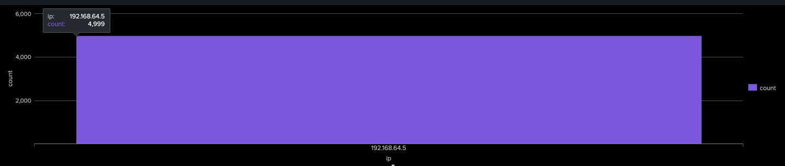

In this screenshot the origins of the login attempts were collected, it is shown that the attack was initiated from a single origin “192.168.64.5”. This figure highlights the importance of checking the origin s from which the requests were sent, a standard approach to counter such requests can be firewall installments.

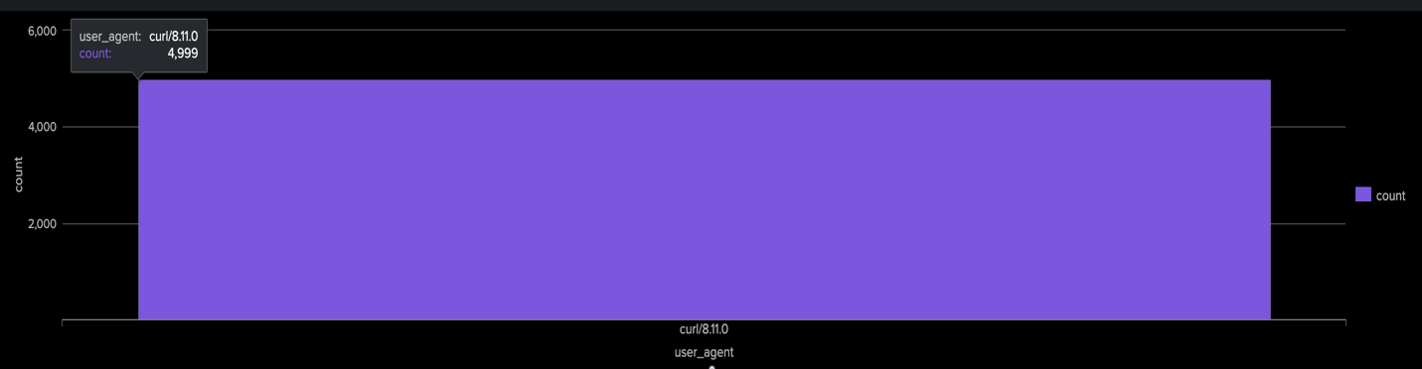

This figure discusses the user agent employed by the attacker, it is shown that all the 4,999 requests were sent using curl/8.11.0.

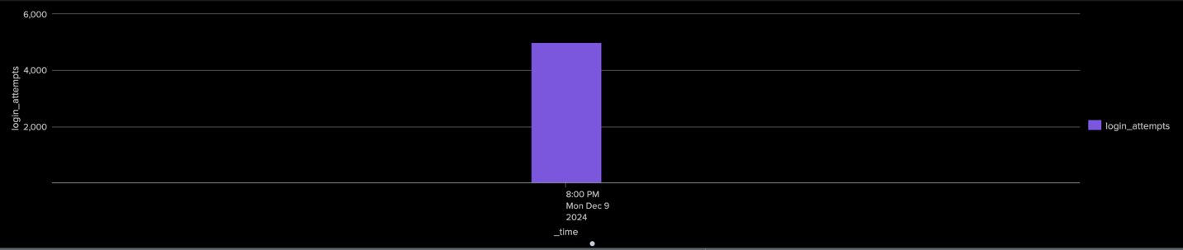

In here, we can study the timeline at which the attacker started flooding the server with requests. We can see that the attack took place at around 8:00 PM.

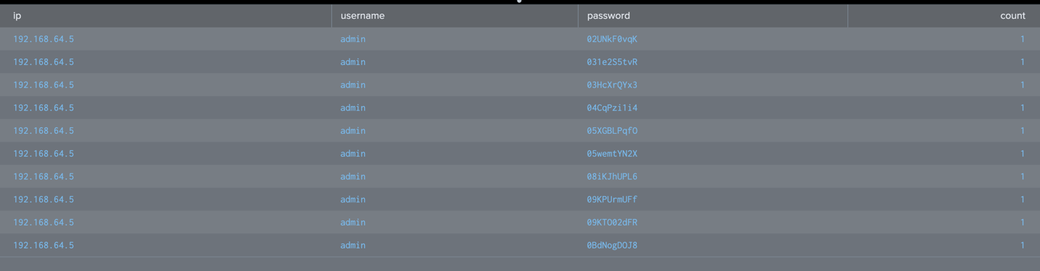

Finally, from this table we can look at suspicious attempts conducted by the attacker. Here is a sample of admin login attempts, we can see that the passwords are not easily guessed and look real, which emphasizes a high degree of importance on secure login methods such as 2FA.